AWS Lab 1: Introduction to AWS IAM

Joshua Widjaja

P0-2 Cisco CCNP

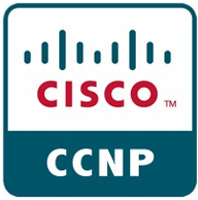

**Purpose:**

Purpose of this lab was to first get us familiar with the controls and widgets in accessing the AWS management console. The main focus was centered around the introduction to AWS Identity and Access Management (IAM). In this lab we explored pre-created IAM Users and Groups, inspected IAM policies as applied to the pre-created groups, added users to groups with specific capabilities enabled in a real-world scenario, used the IAM sign-in URL, and experimented with the effects of policies on service access.

**Background Information:**

The main concept of this lab was the basic functions of AWS Identity and Access Management (IAM). This particular attribute of AWS enables their customers to manage users and user permissions within AWS. Using IAM, you can centrally manage access to launching, configuring, managing, and terminating resources in your AWS account. You can also manage which resources can be accessed by who, and how these resources can be accessed. For example, as the user you might allow some users full access to Amazon DynamoDB, but allow others read-only access to Amazon Dynamo DB. An amazing quality about AWS IAM is that it is a no-cost AWS account feature. The four IAM components are IAM user, group, policy, and role.

|  |  |
| --- | --- |
| IAM User | A person/application that can authenticate with one AWS account. Each user must have a unique name and security credentials that aren’t shared with other users. |
| IAM Group | A collection of IAM users granted identical authorization. You can use IAM groups to simplify specifying and managing permissions for multiple users. |
| IAM Policy | A document defining permissions to determine which resources can be accessed and the level of access to each resource. |
| IAM Role | An applicable tool for granting temporary access to specific AWS resources in an AWS account. It can be used to grant a set of permissions for making AWS service requests. |

By default, IAM users don’t have permissions to access any resources in their AWS account. The root user must explicitly grant permissions to a user, group, or role by creating an IAM policy. A user must be authorized (given permission to services) before accessing AWS services. The principle of least privilege is the best practice, saying that you should grant only the minimal user privileges needed.

There are two types of IAM policies. First of all, identity-based policies are policy permissions that you can attach to an identity such as an IAM user, group, policy, or role. They control what actions they can perform, on which resources, and under what certain conditions. Second of all, Resource-based policies control what actions a specific principal can perform on a resource and the conditions.

**Lab Summary:**

1. Access the AWS Management Console
2. Explore the Users and Groups: Using user-1, view user group permissions for various AWS applications.
3. Work with users and groups to enable permissions using the given business scenario.
4. Add Users to Groups: You will be adding user-1 to S3-support group, user-2 to EC2-support group, and user-2 to EC2-admin group.
5. Sign-In and Test Users

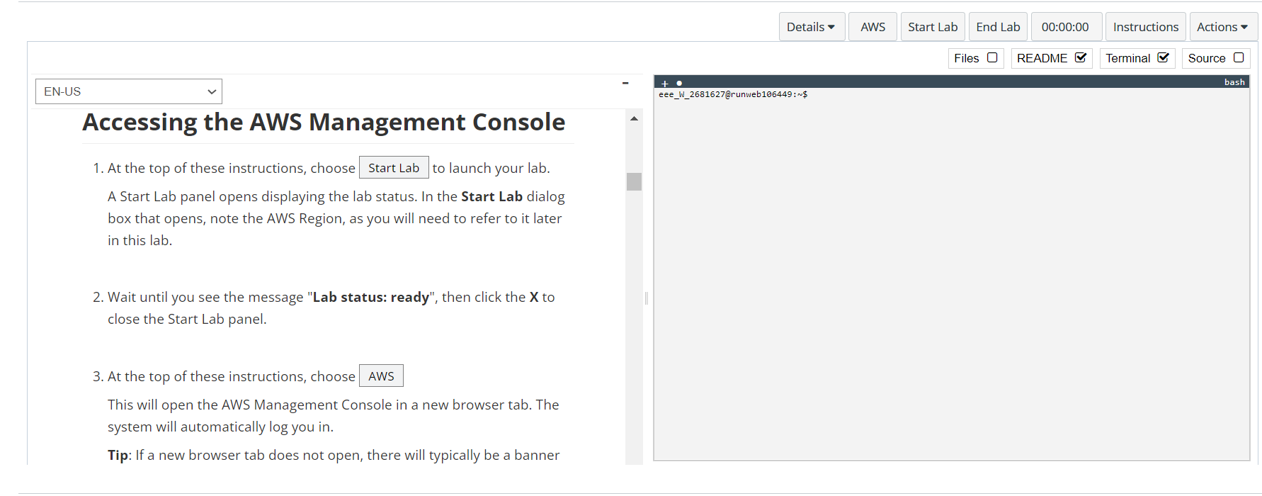**Configurations:**

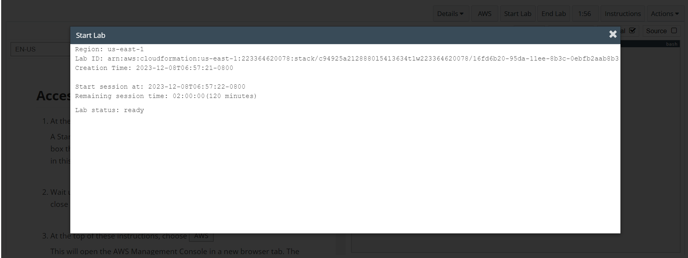

You are taken to this window. It takes a while but once you receive the message “lab status: ready” you can exit out.

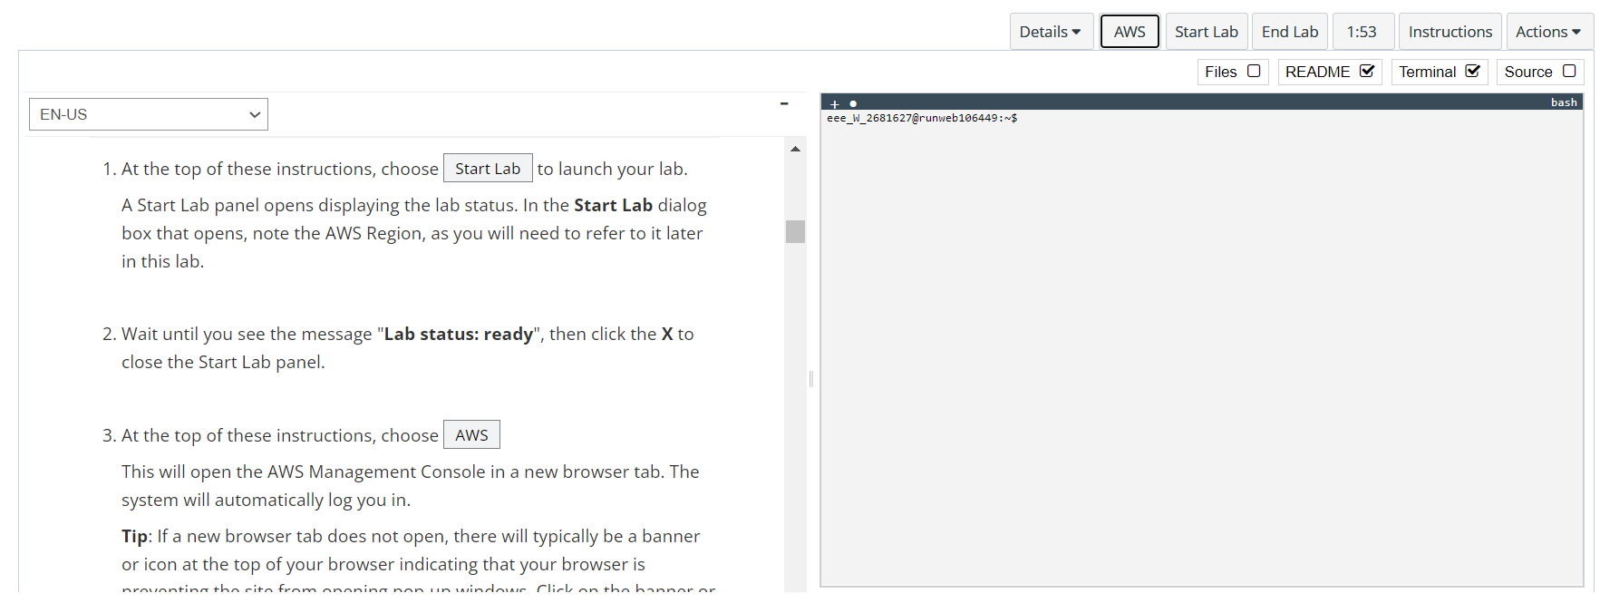

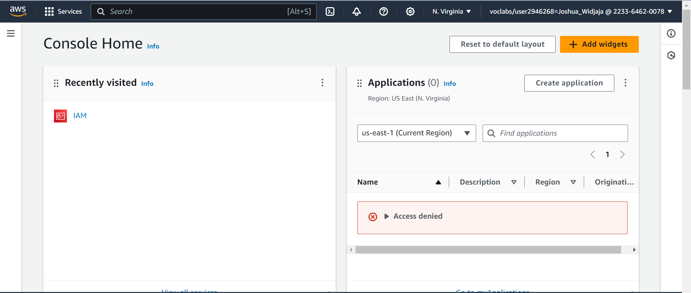

You are then prompted to a new tab in your browser. Then click the 3 horizontal lines in the management console.

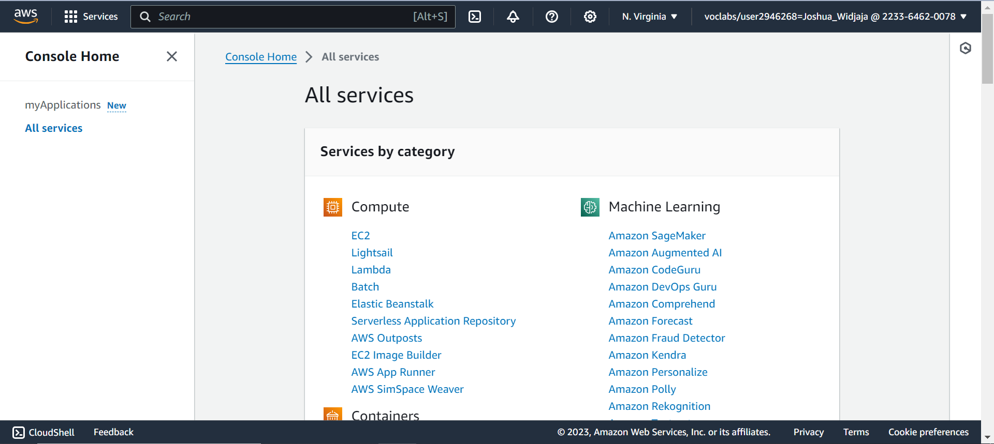

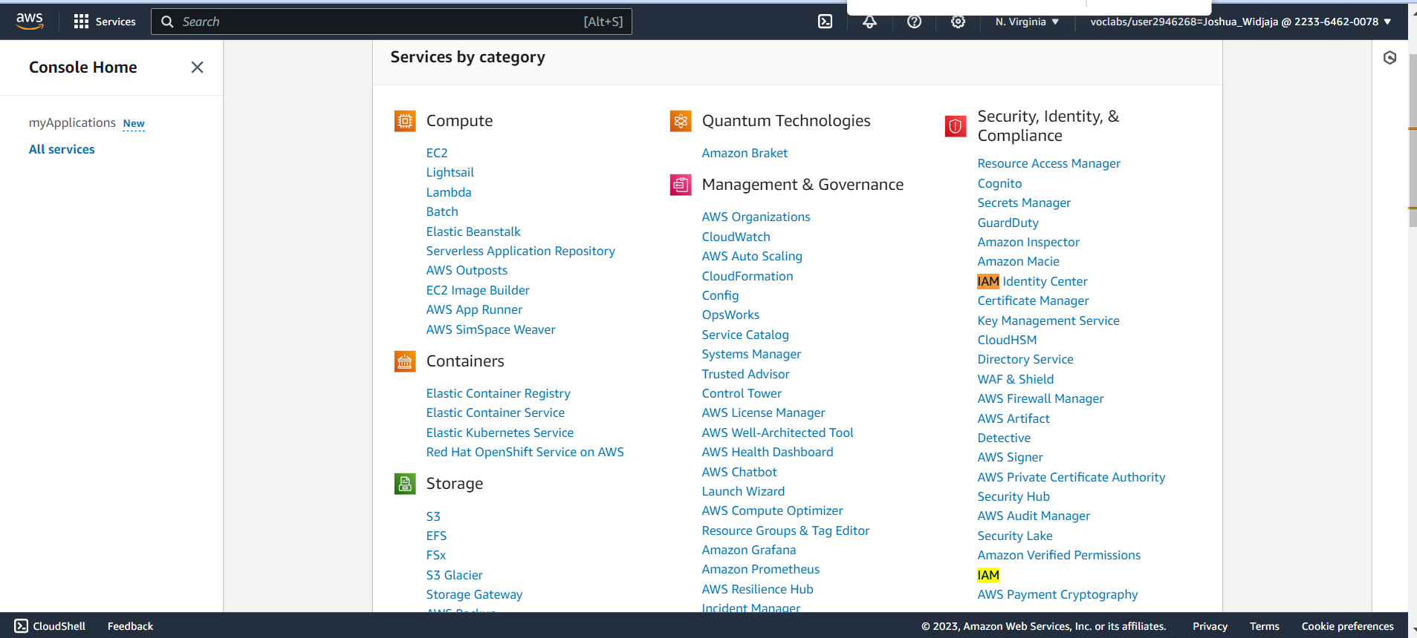

Under Security, Identity, and Compliance, select “IAM”

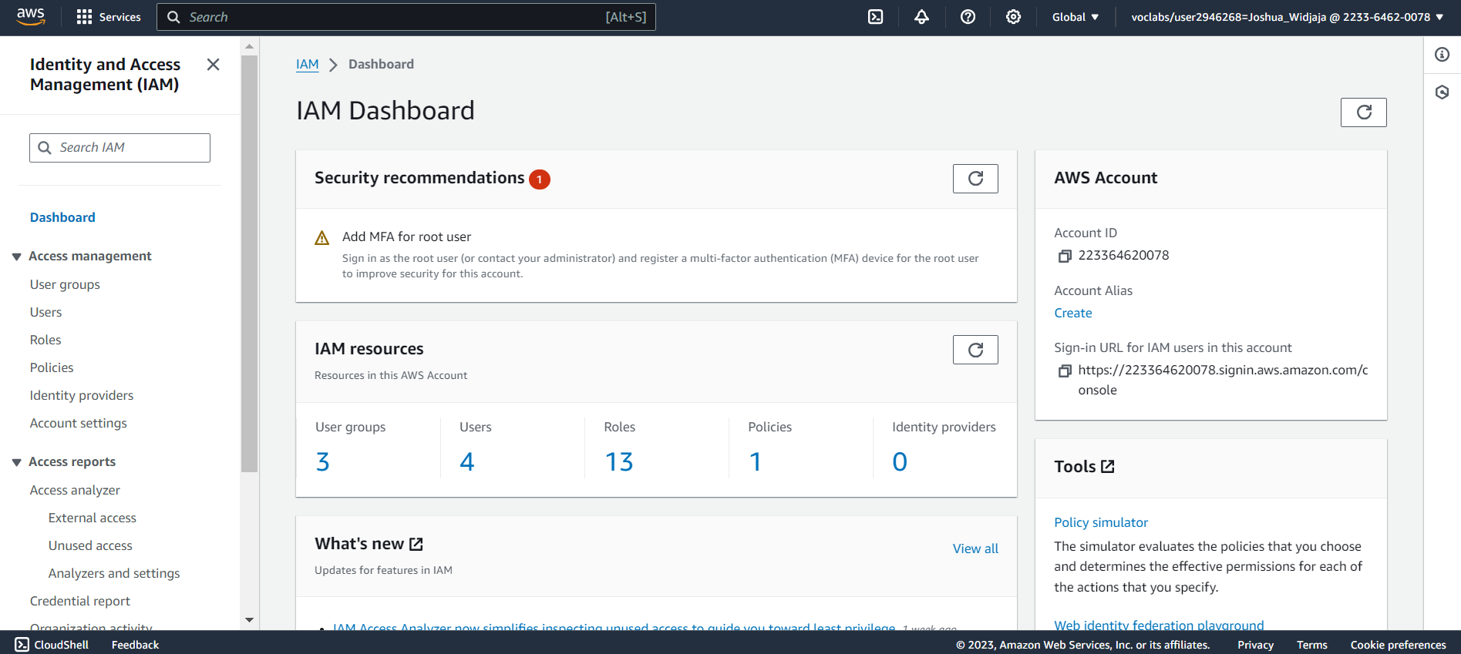

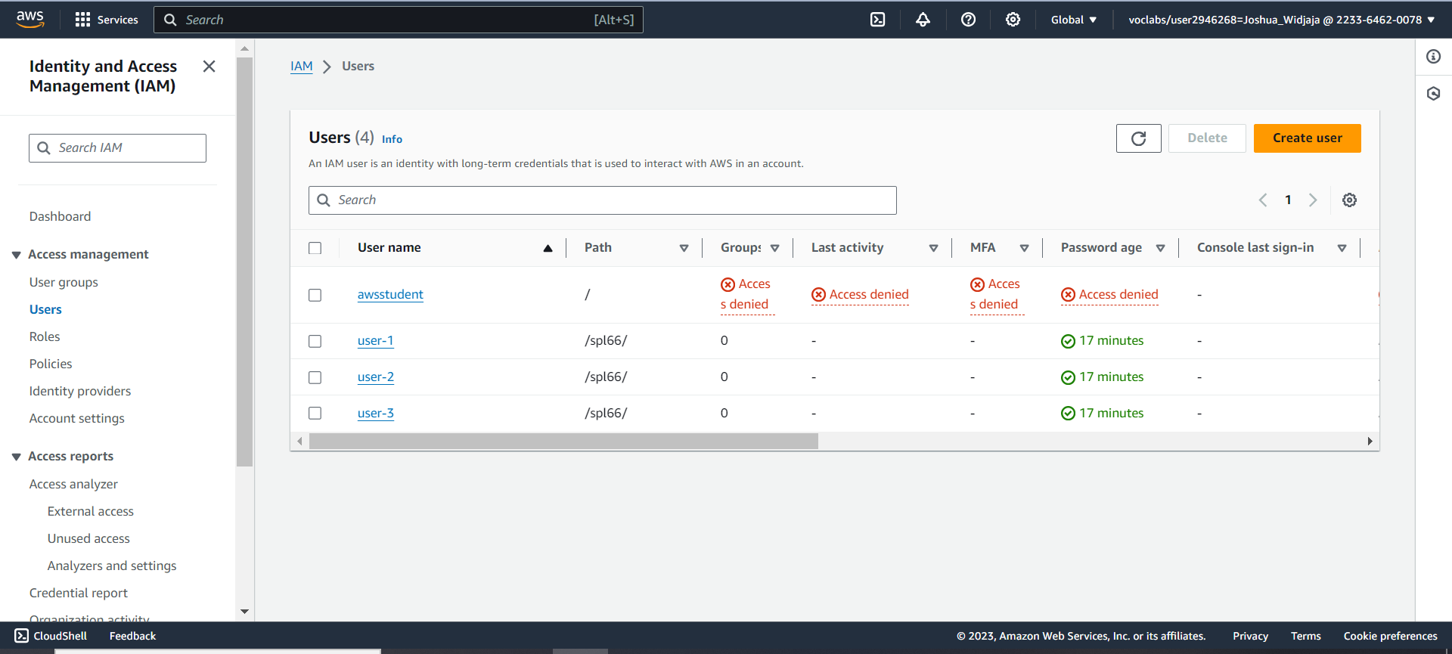

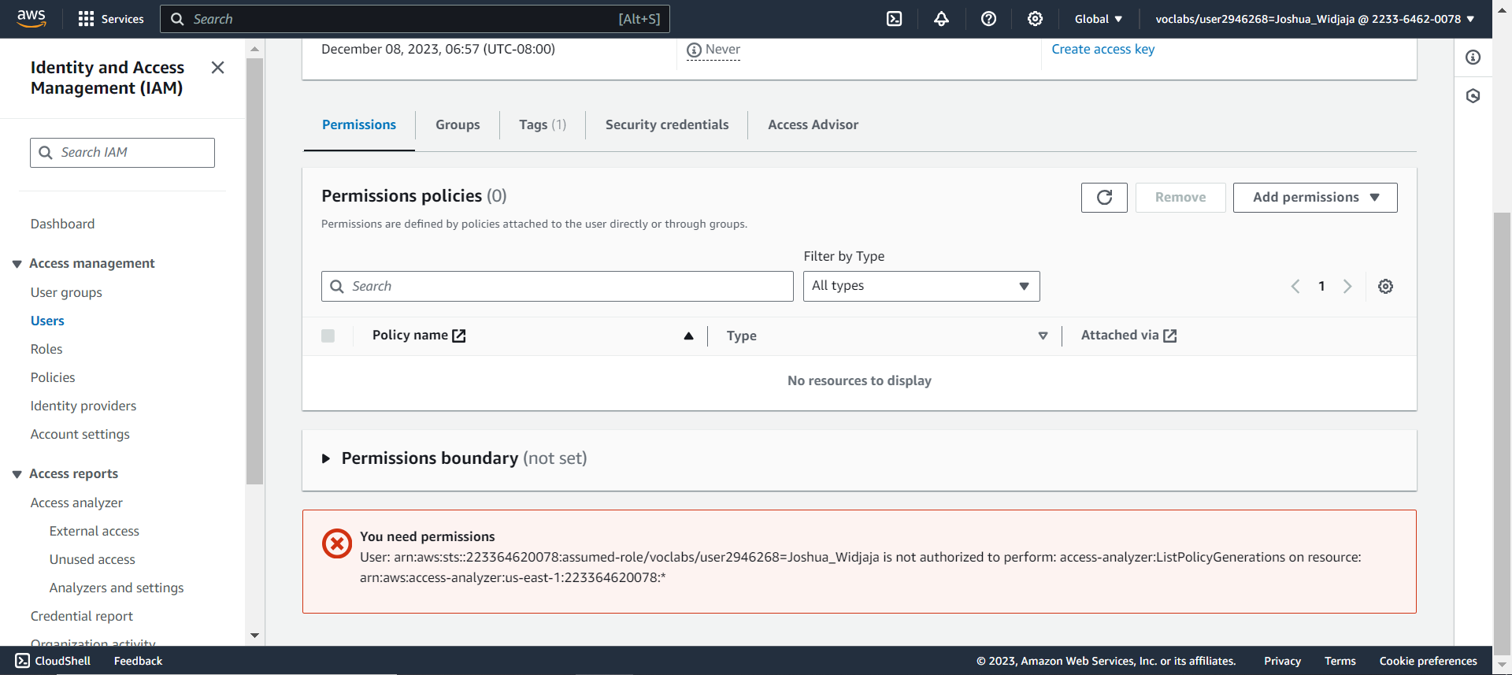

Notice that there are no permissions for user-1. Click on the groups tab.

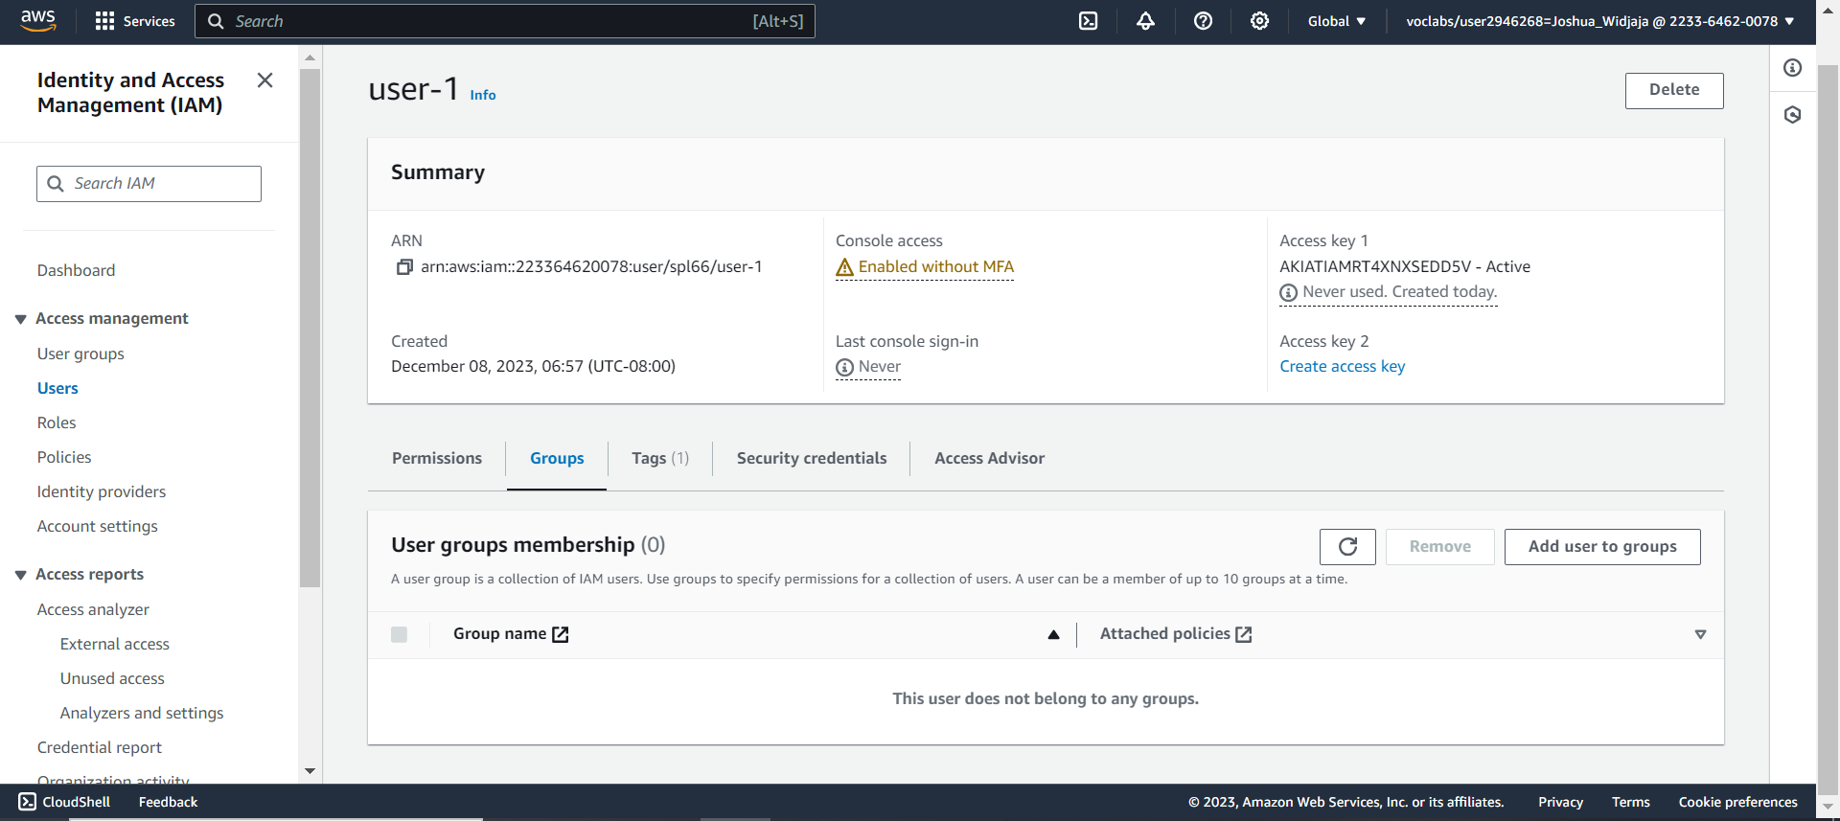

Notice that it does not belong to any groups. Next click on security credentials tab.

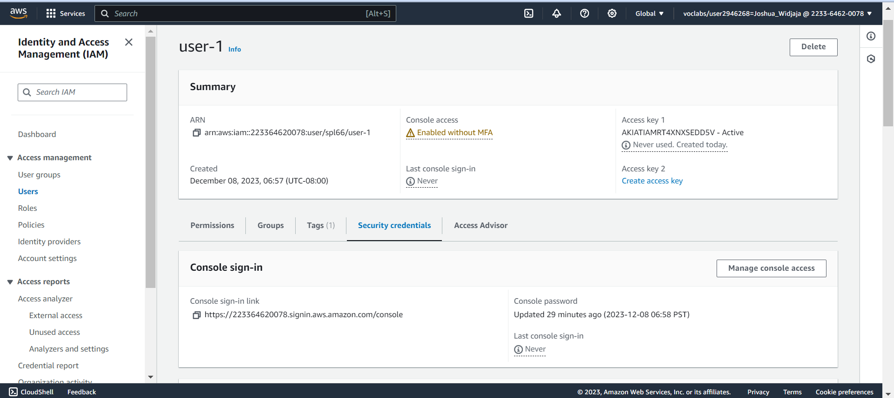

Notice that a console password is set up. Click onto user groups next.

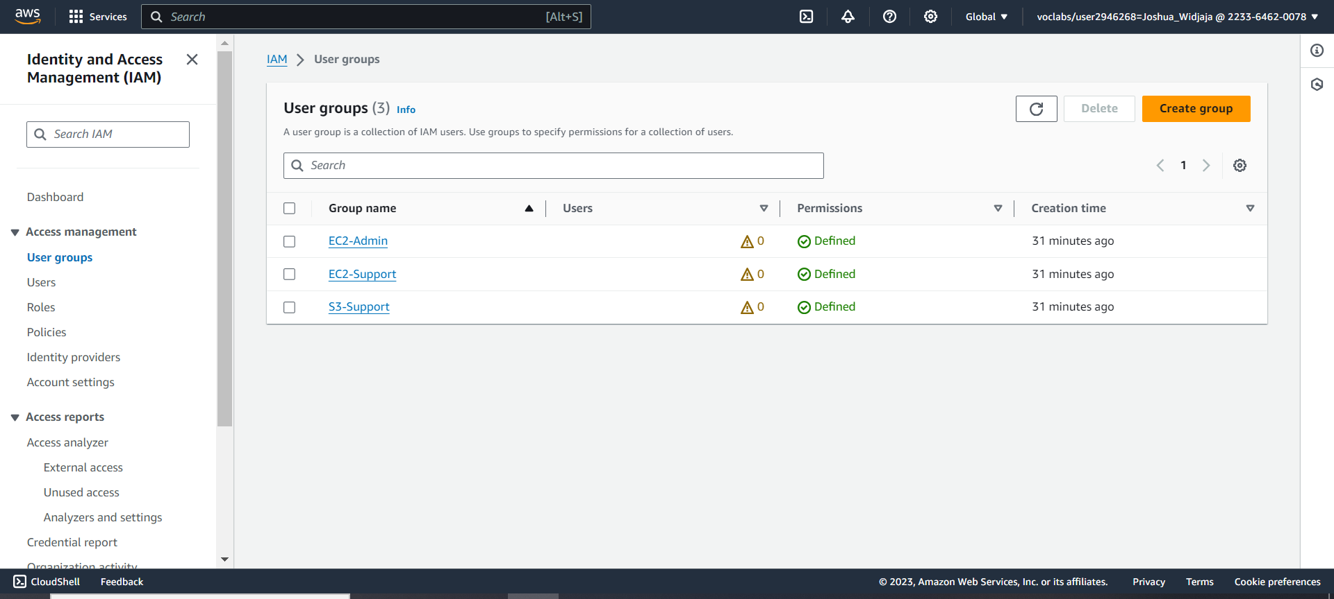

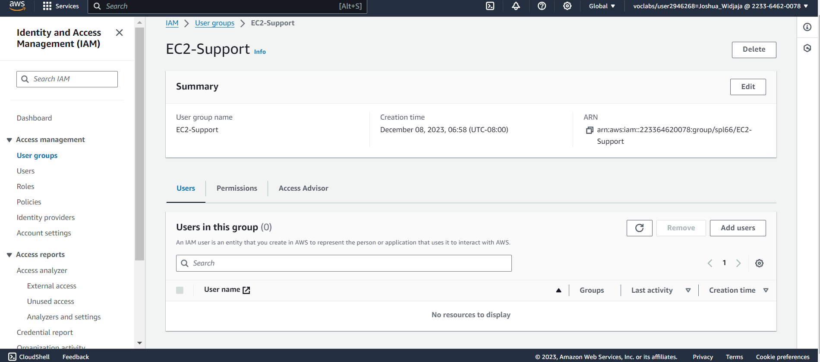

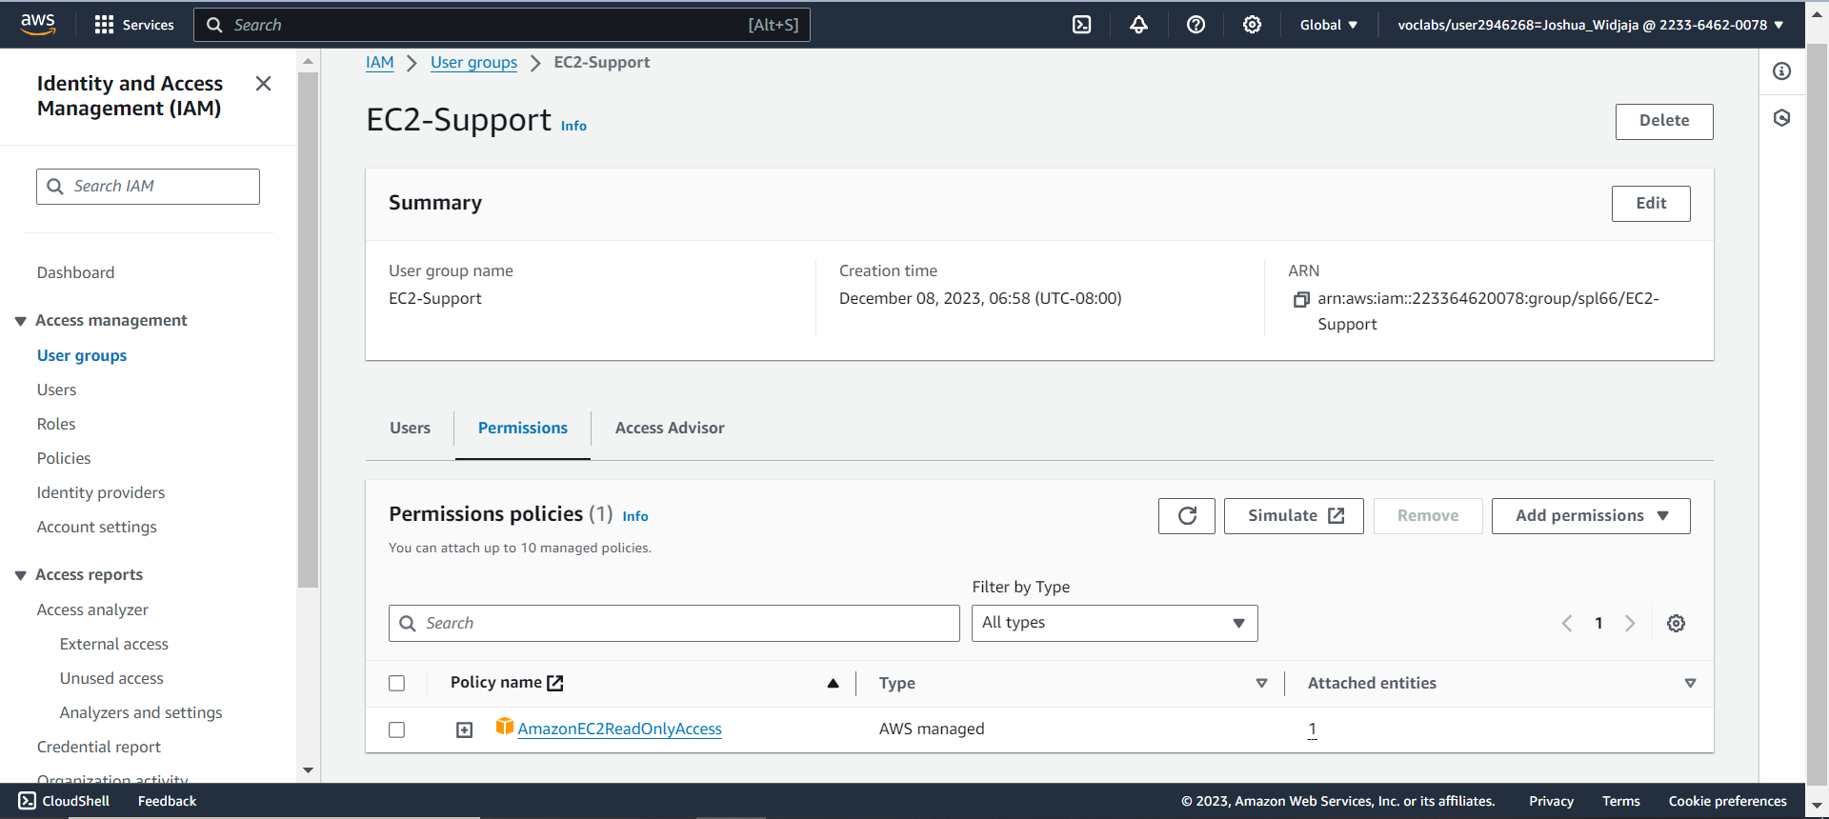

Click plus to view the policy details.

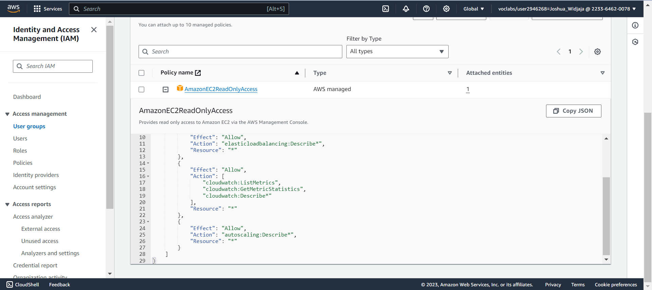

After viewing amazonec2readonlyaccess, click minus sign to close out. Afterwards, click on user groups.

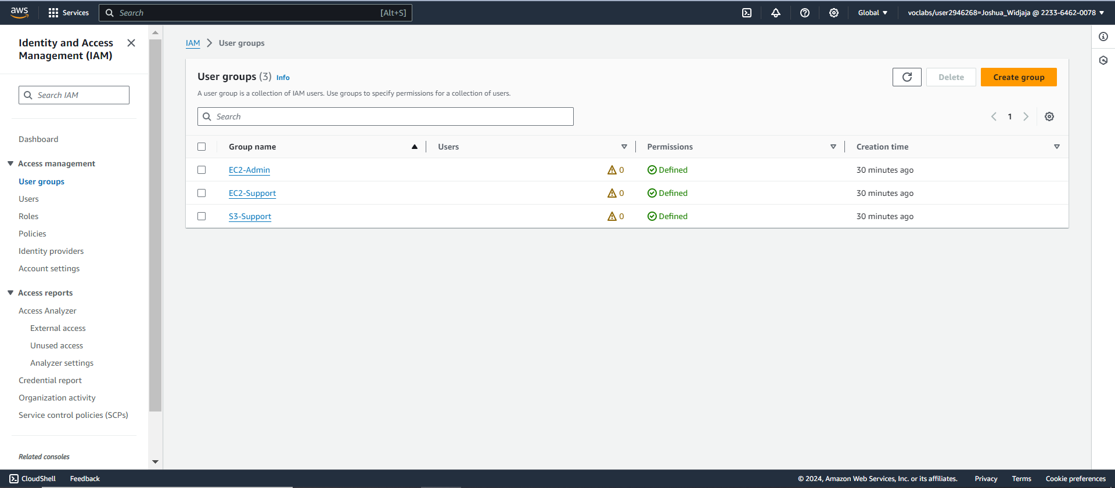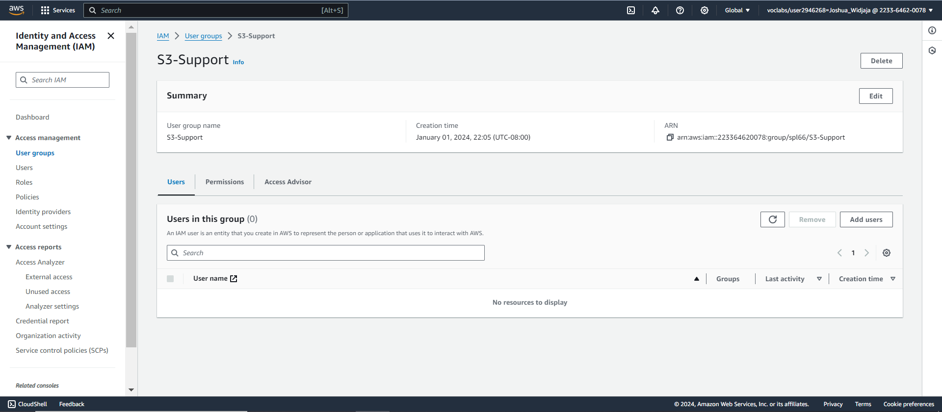

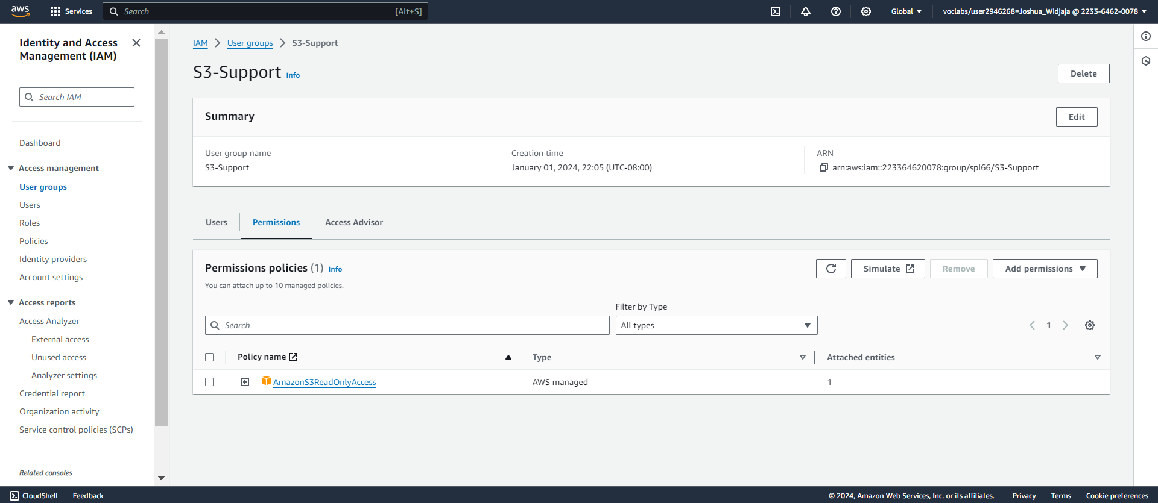

Click the plus sign next to “AmazonS2ReadOnlyAccess”

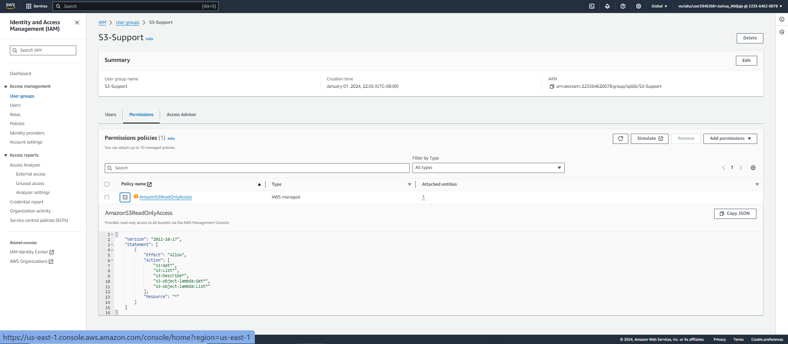

This policy grants permissions to Get and List resources in Amazon S3. Click the minus sign to close.

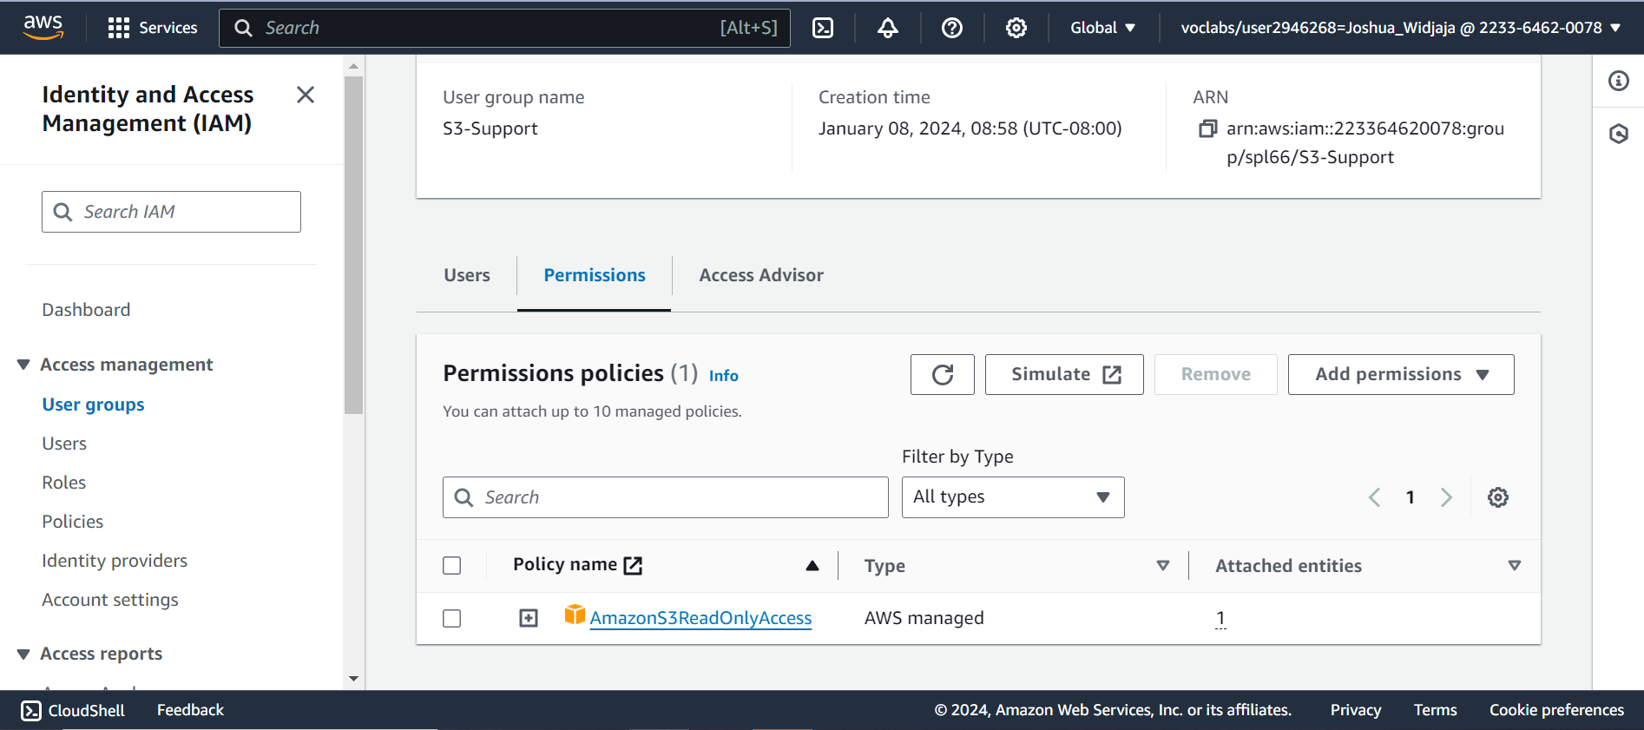

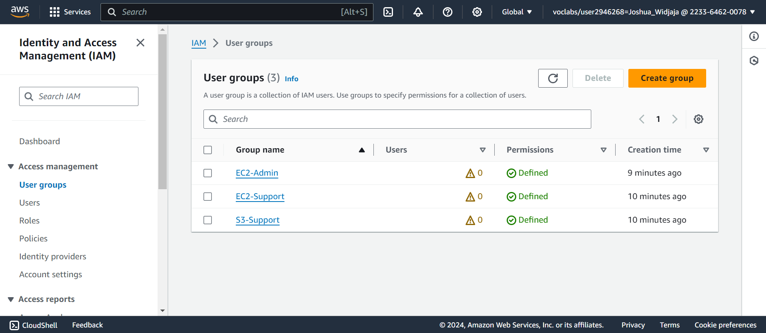

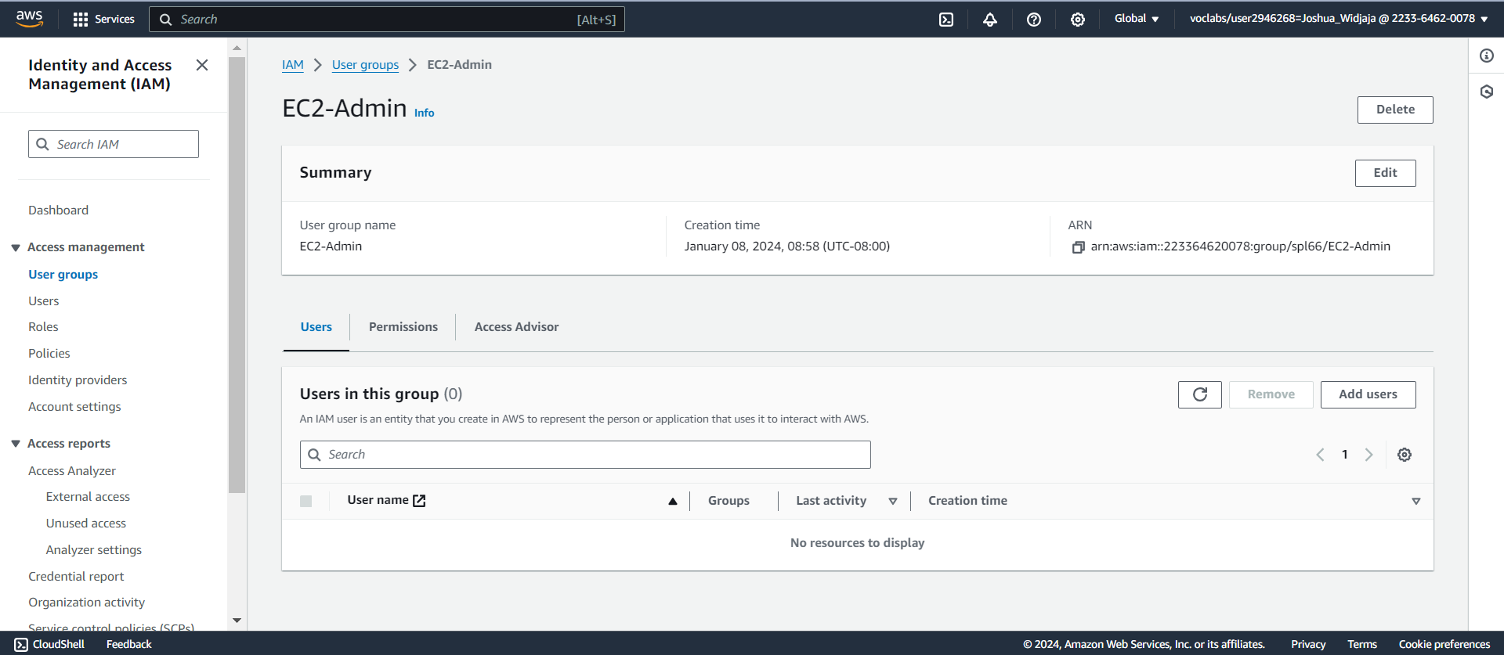

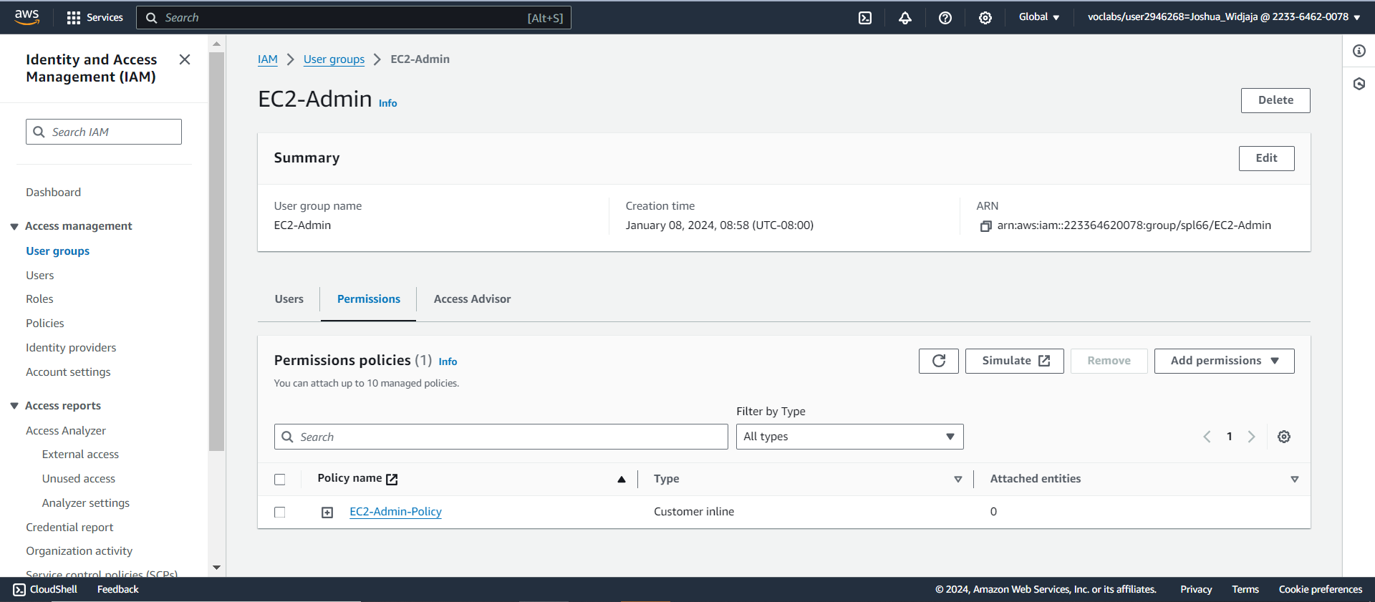

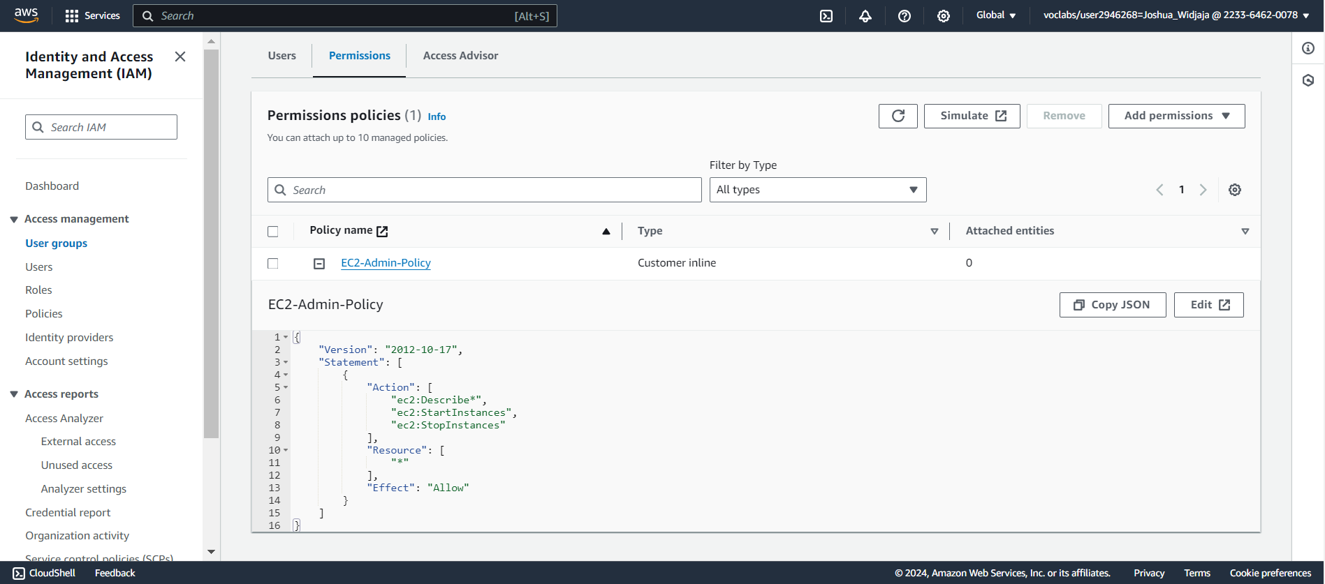

This policy grants permission to view information about Amazon EC2 and the ability to start and stop instances. Click the minus icon to hide the policy details.

**Adding user-1 to the S3-Support Group**

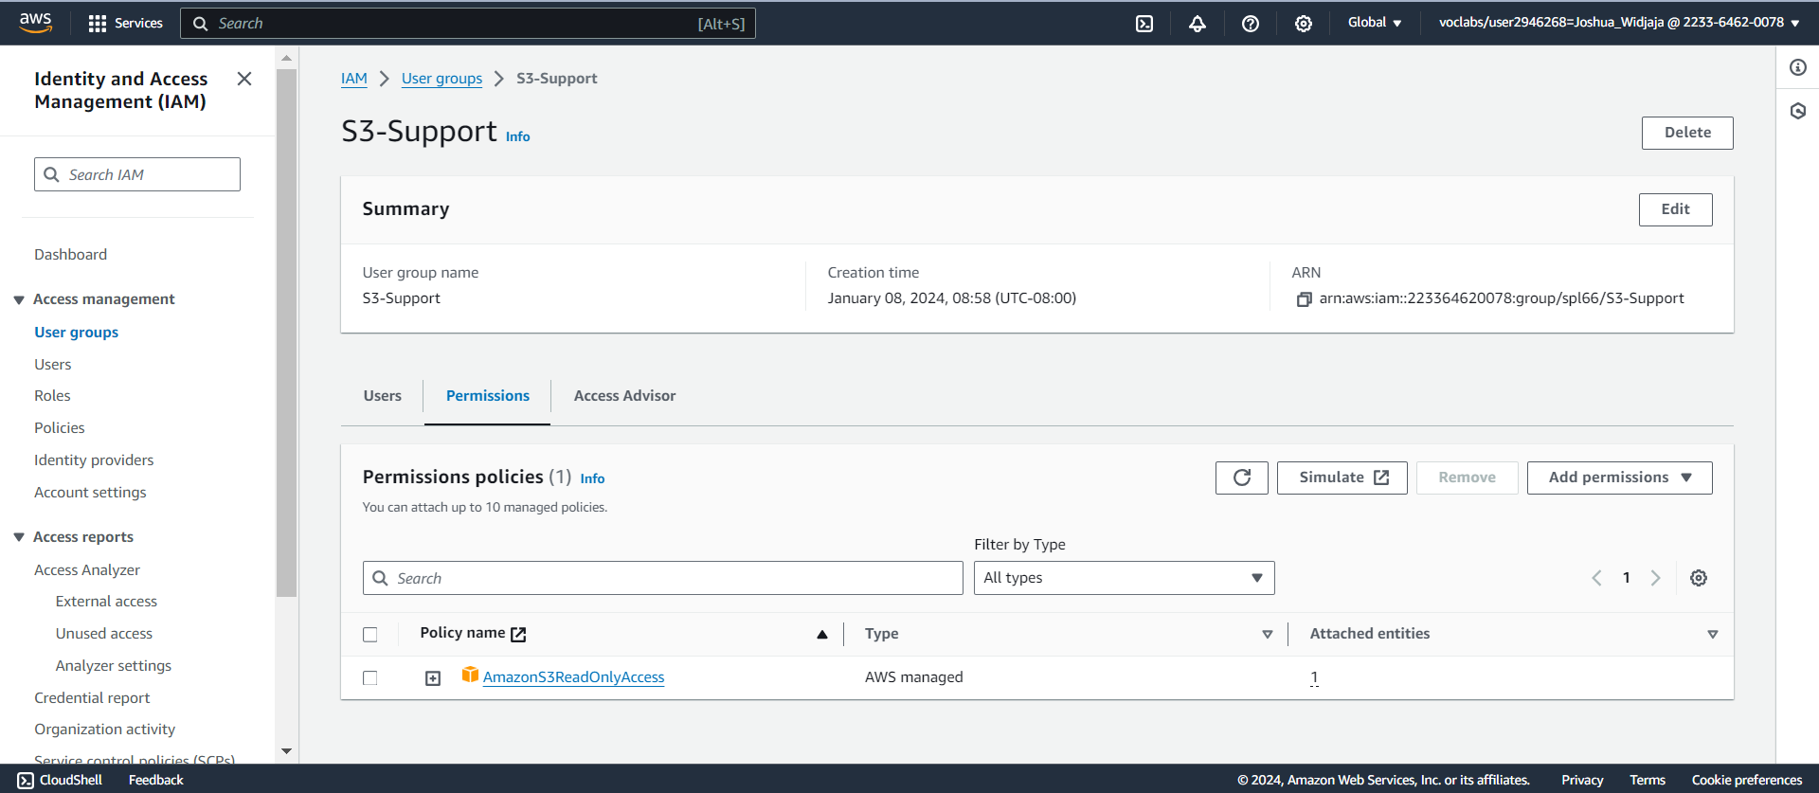

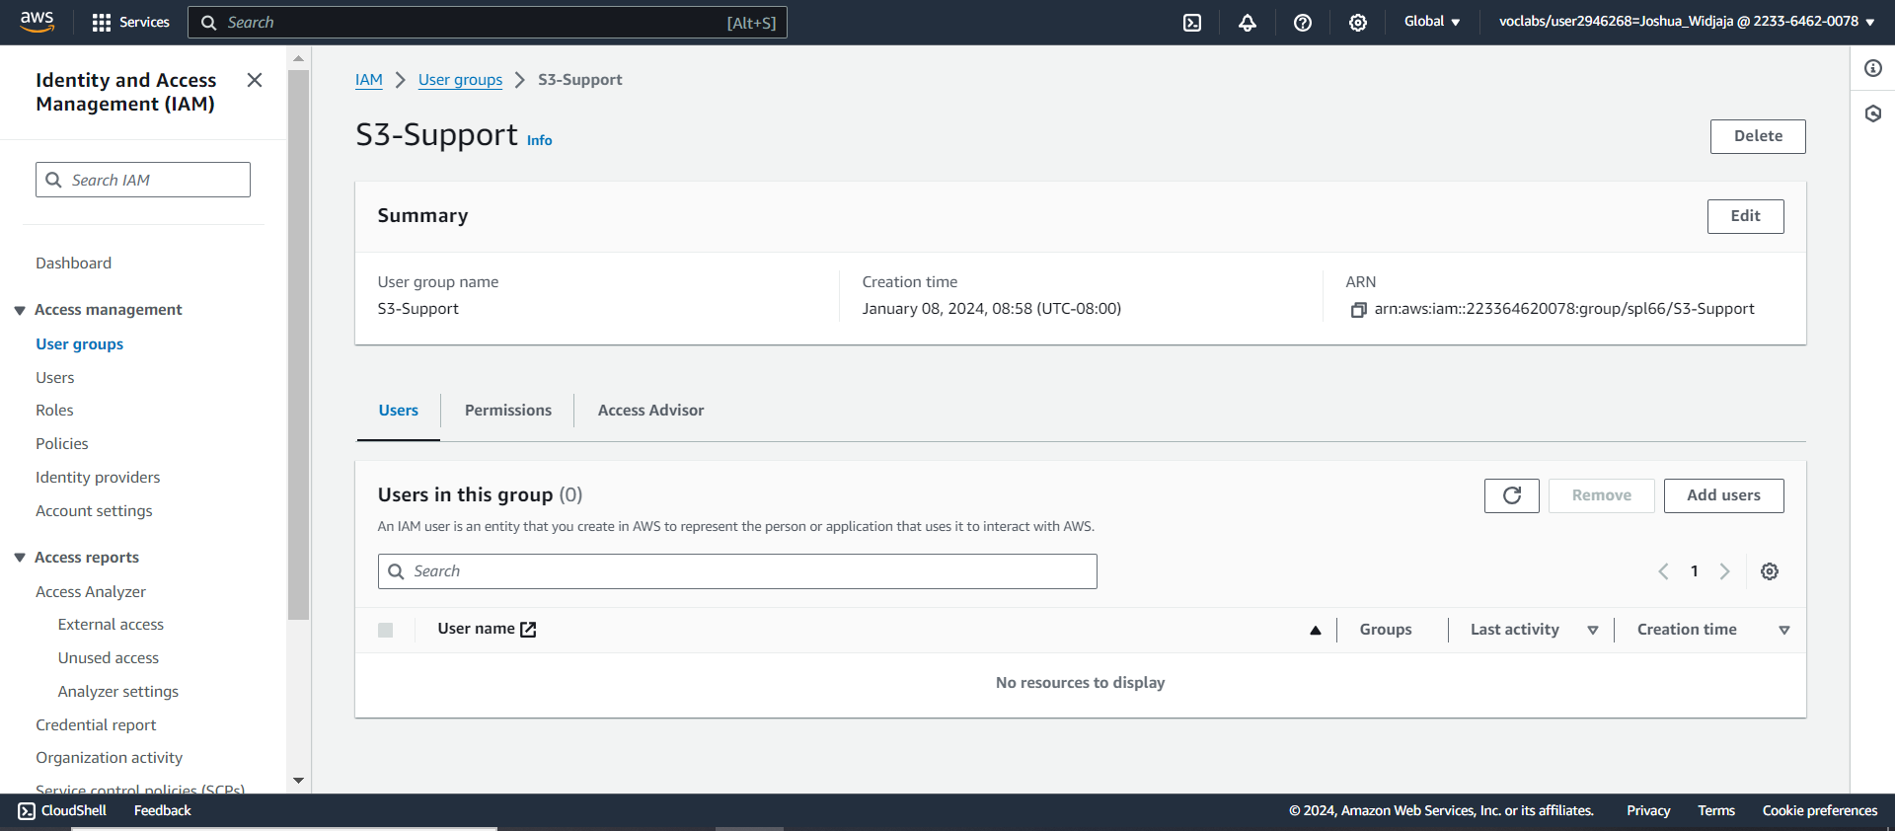

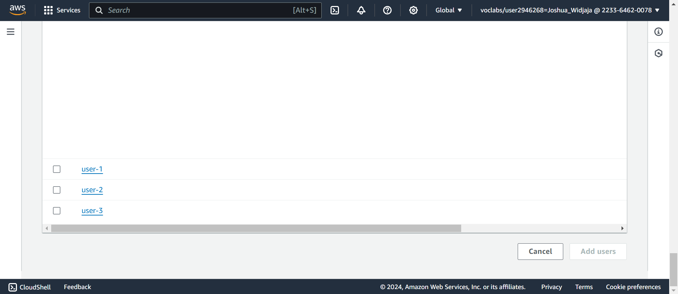

Scroll all the way to the bottom of the screen and check the box next to “user-1”

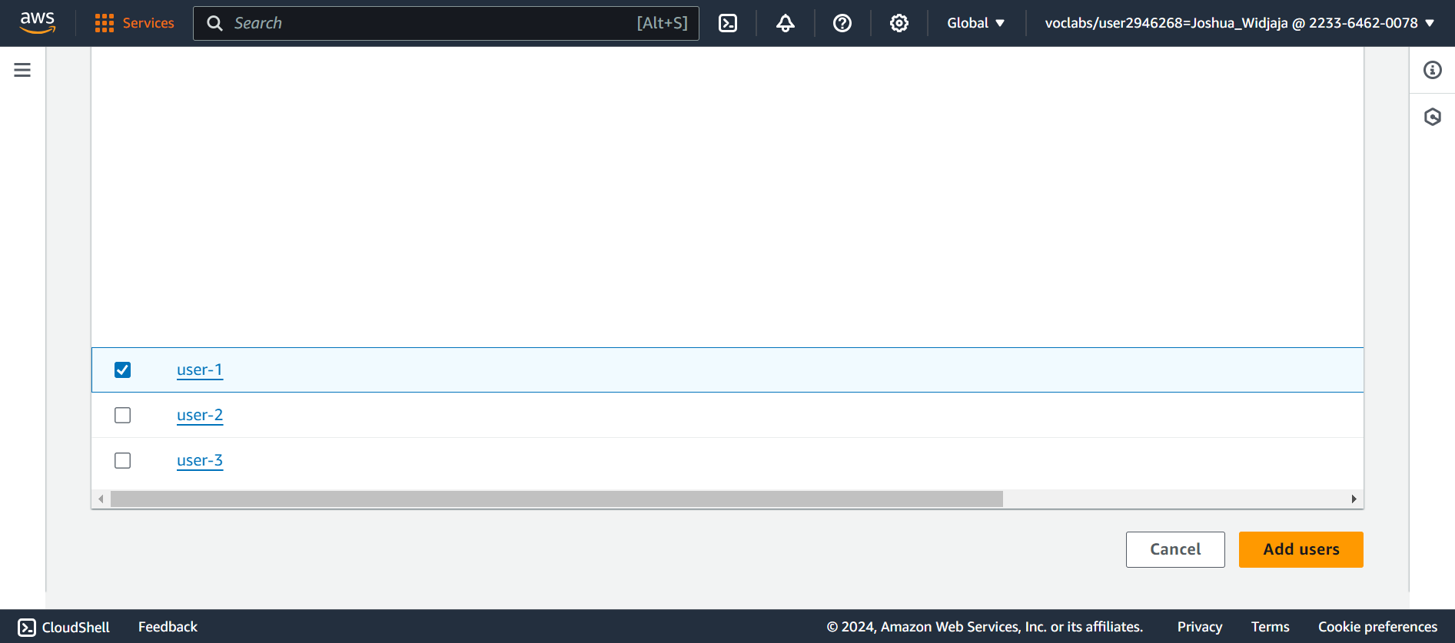

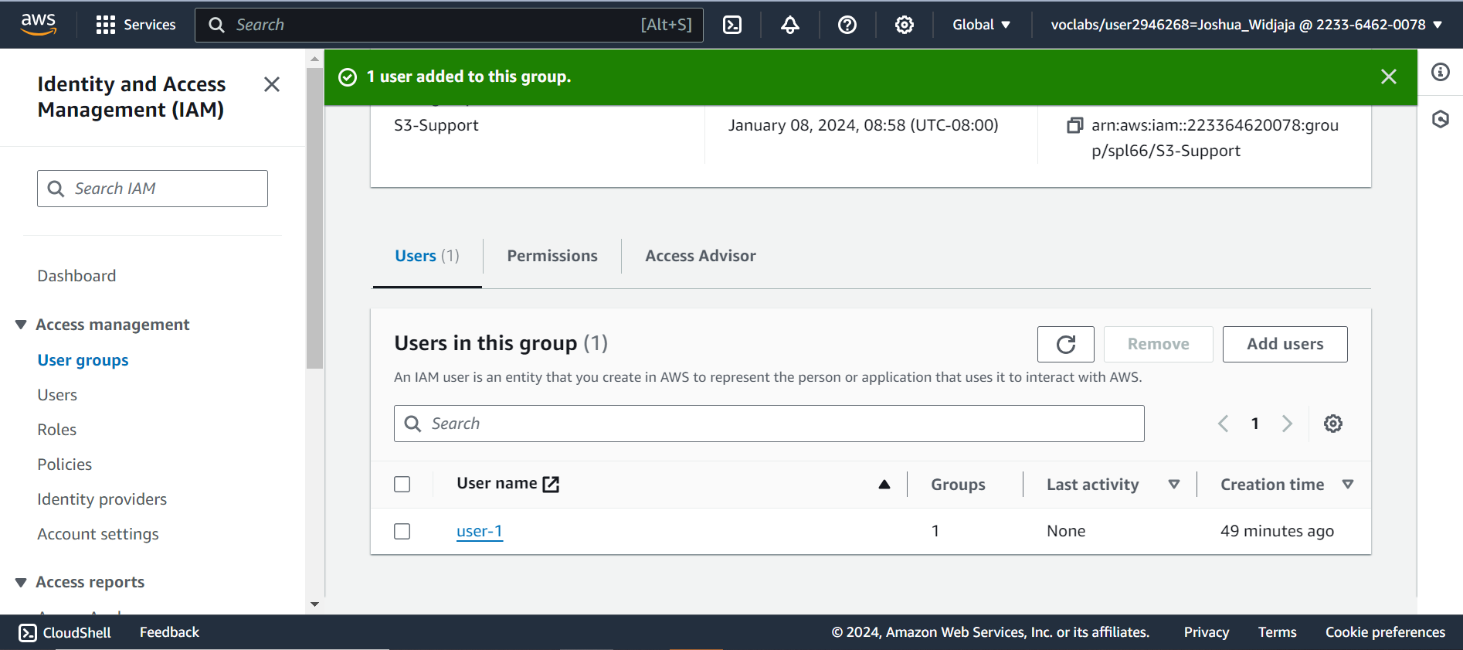

You will see that user-1 has been added to the group. Go back to user groups.

**Adding user-2 to EC2-Support Group**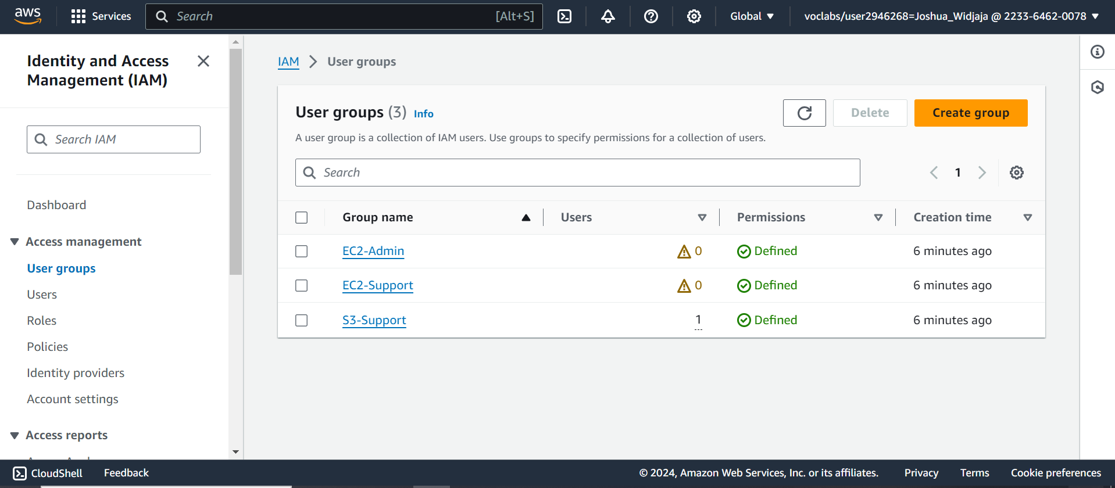

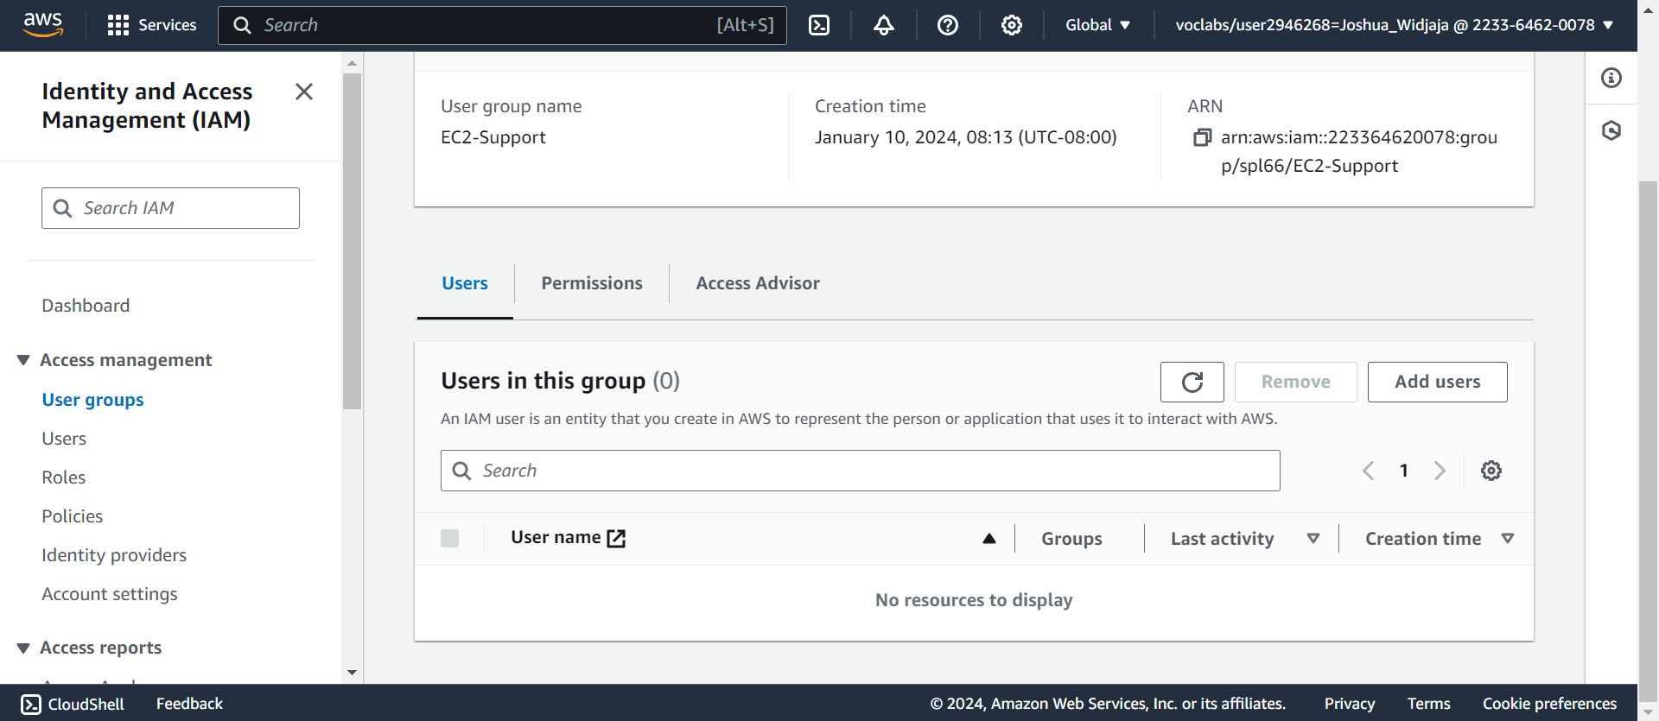

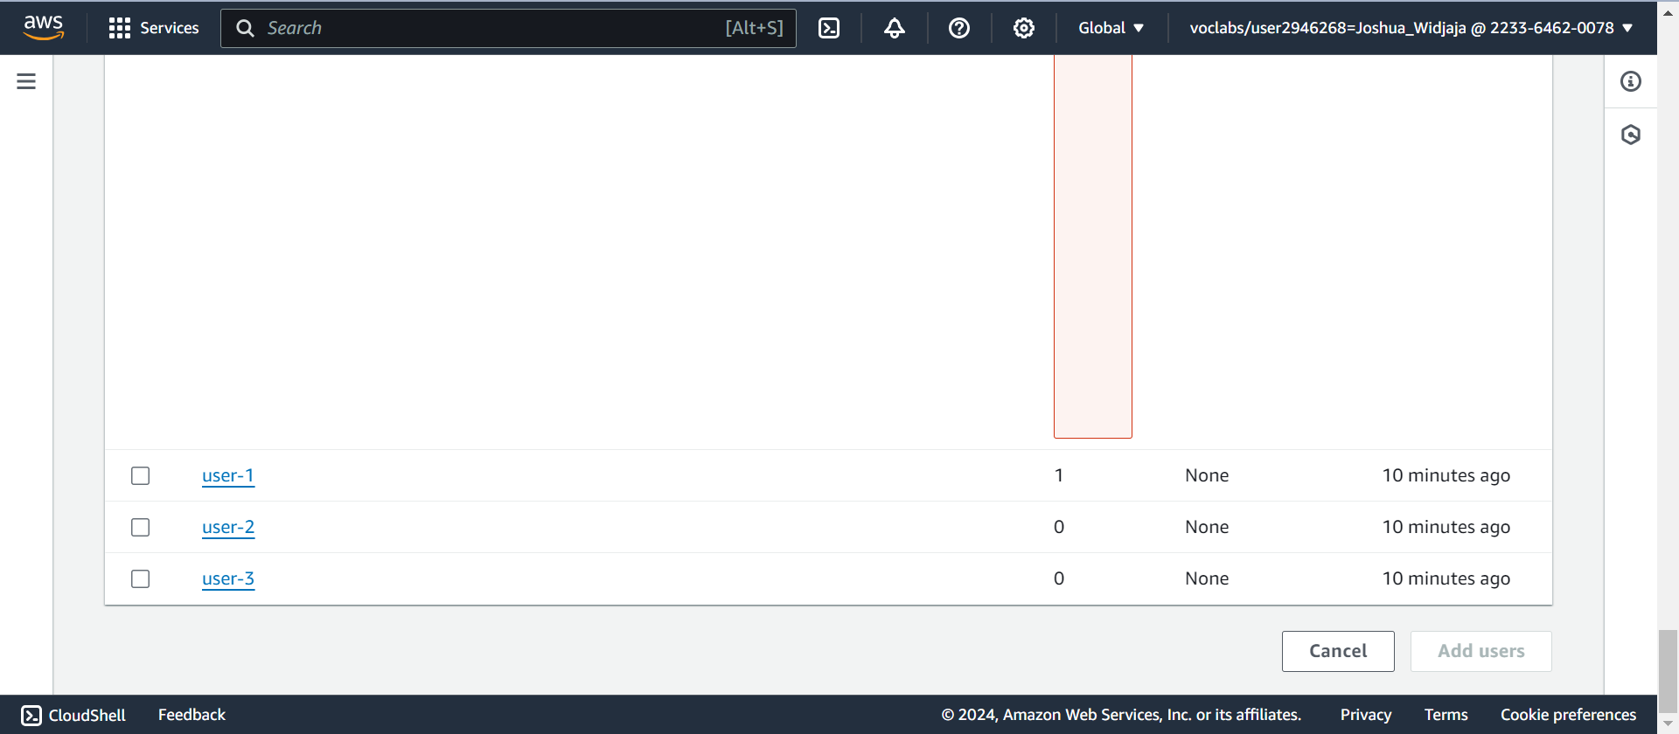

Scroll all the way to the bottom of the page. Check the box next to user-2 and click add users.

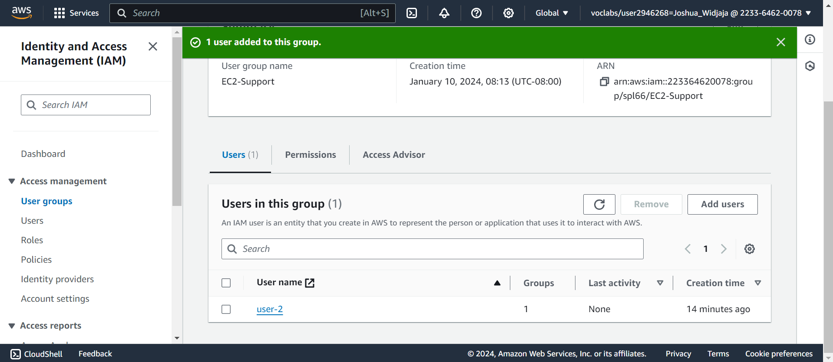You will see that user-2 has now been added to the EC2-Support group. Click back to user groups.

**Add user-3 to the EC2-Admin Group**

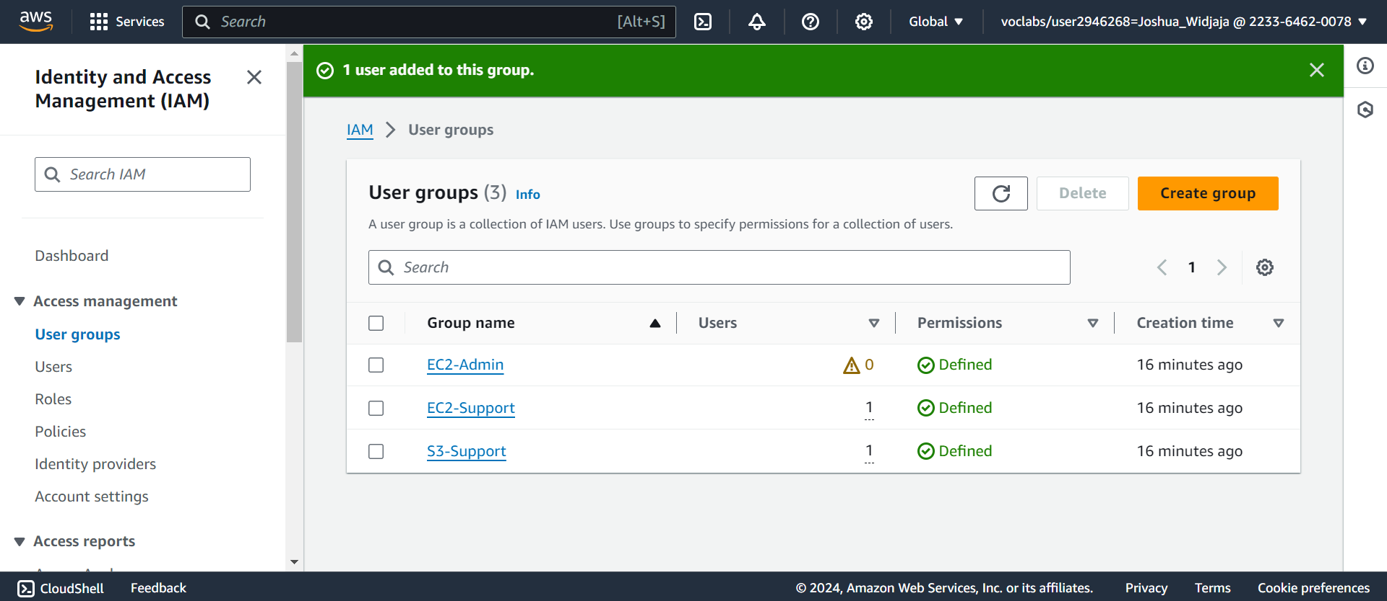

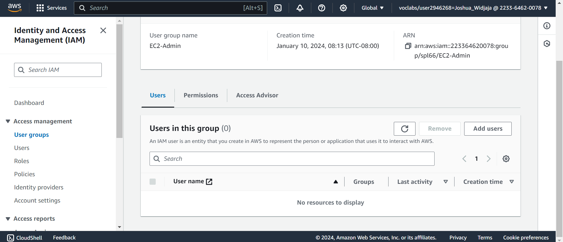

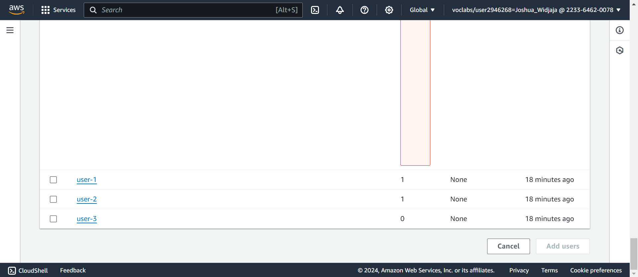Scroll all the way down to the bottom. Check the box next to user-3 and click add user.

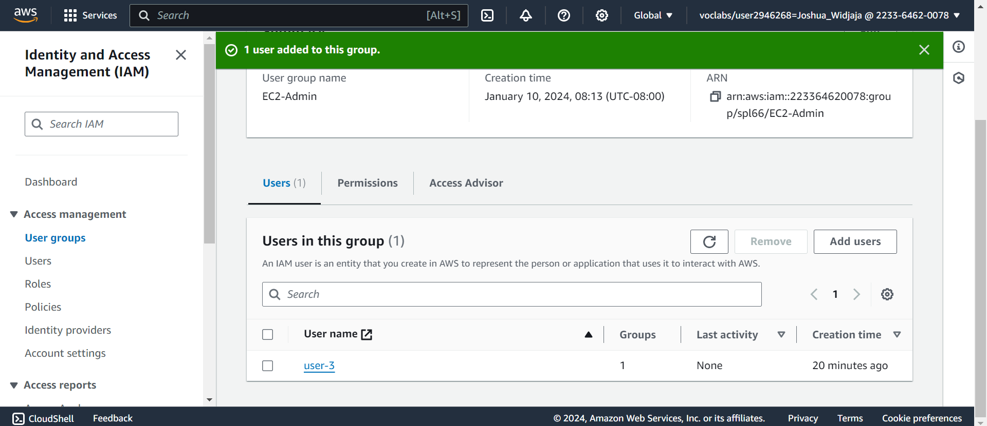

User-3 has been added to the EC2-Admin Group. Click dashboard in the navigation plane.

**Sign-in and Test Users**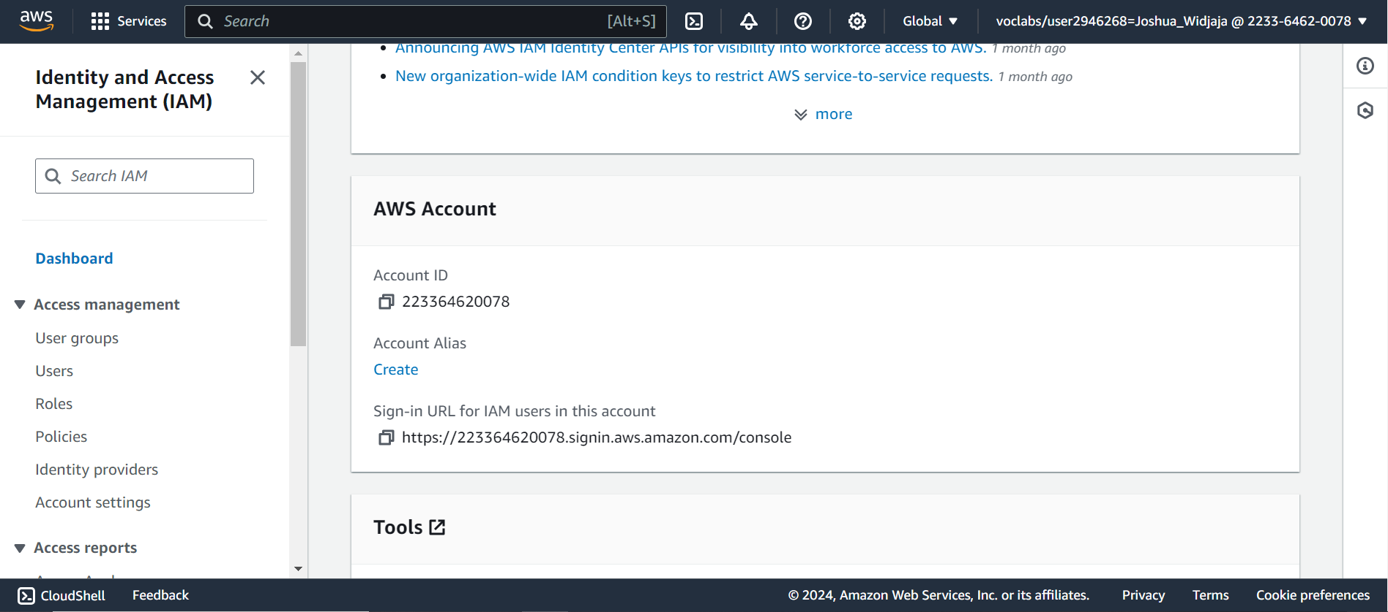

Scroll down to AWS Account and copy the “Sign-in URL for IAM users in this account.”

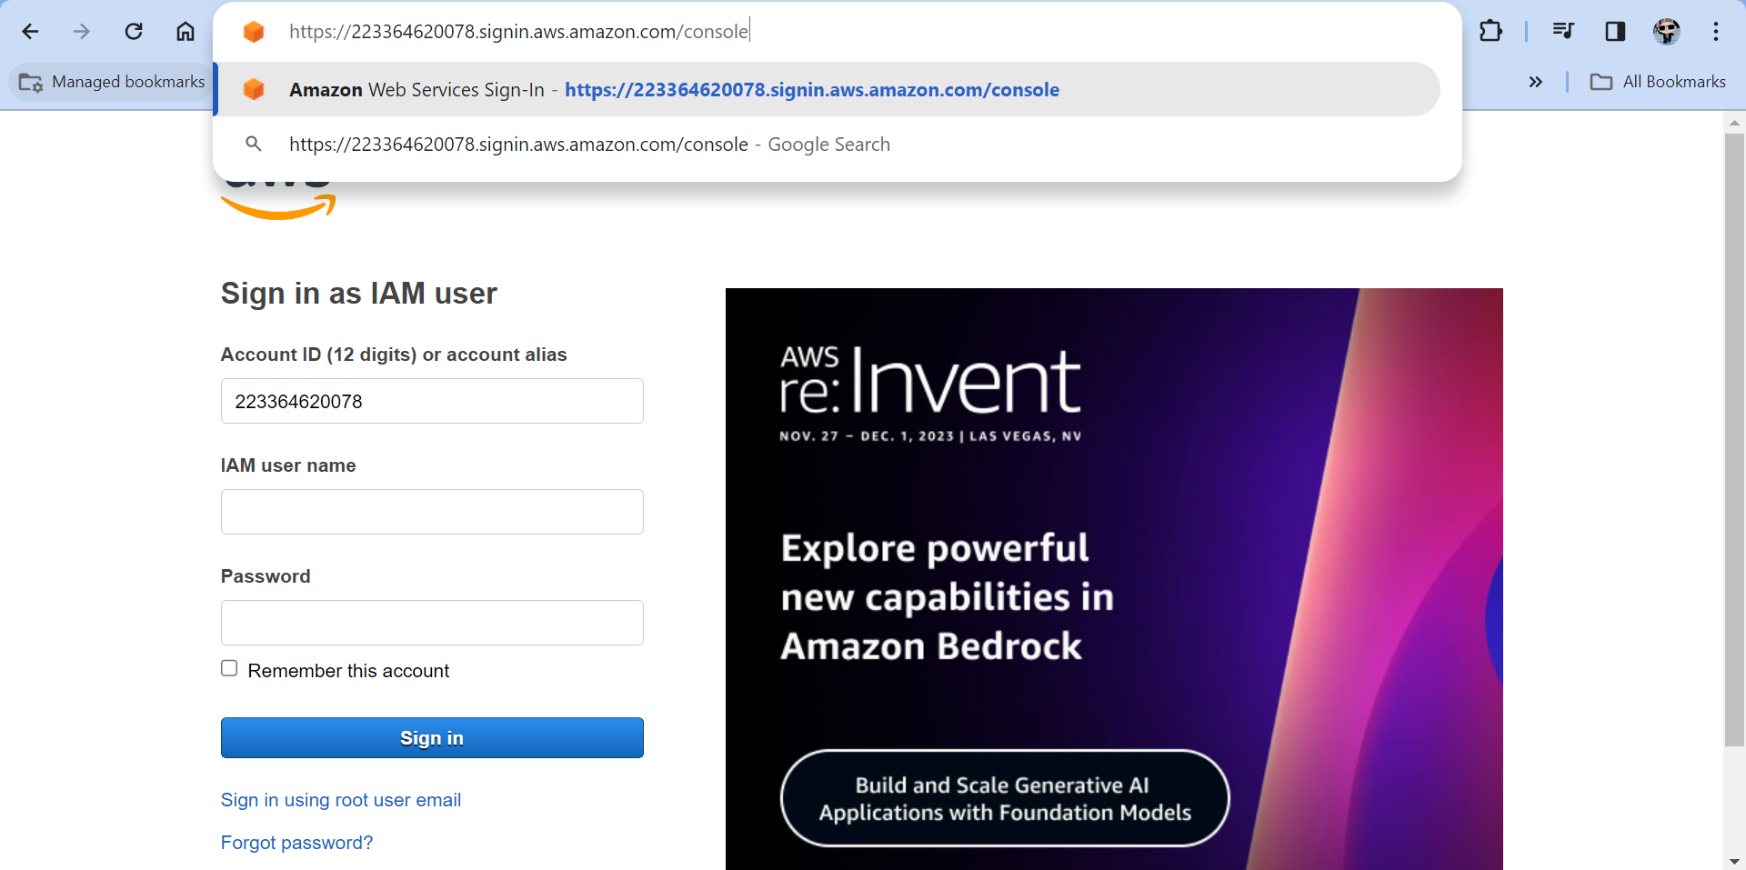

Paste the copied link into a new tab in Google.

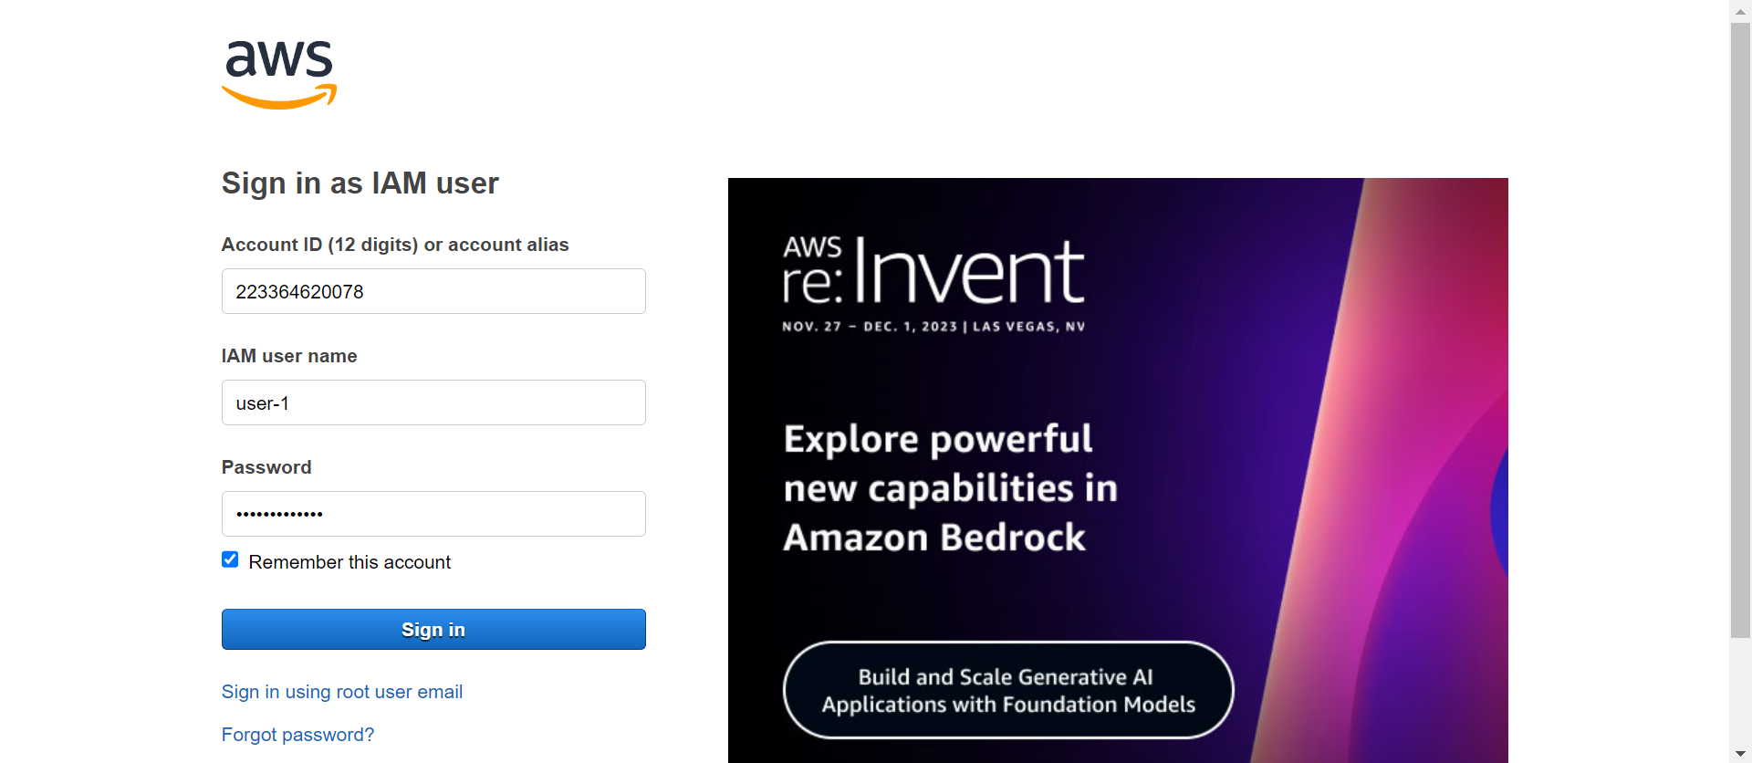

Sign in with: **IAM user name: user-1 – Password: Lab-Password1**

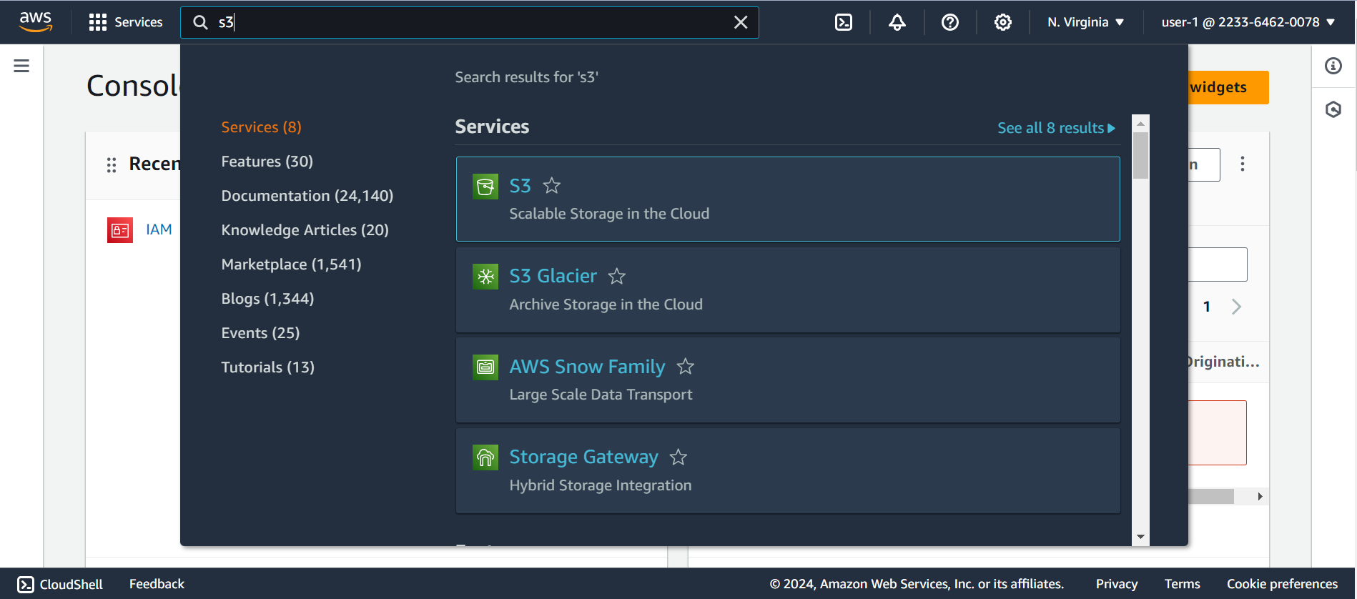

In the Services menu, choose S3.

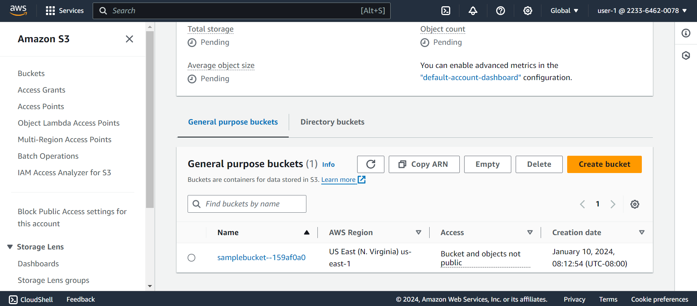

Browse the contents of the bucket that exists in the account.

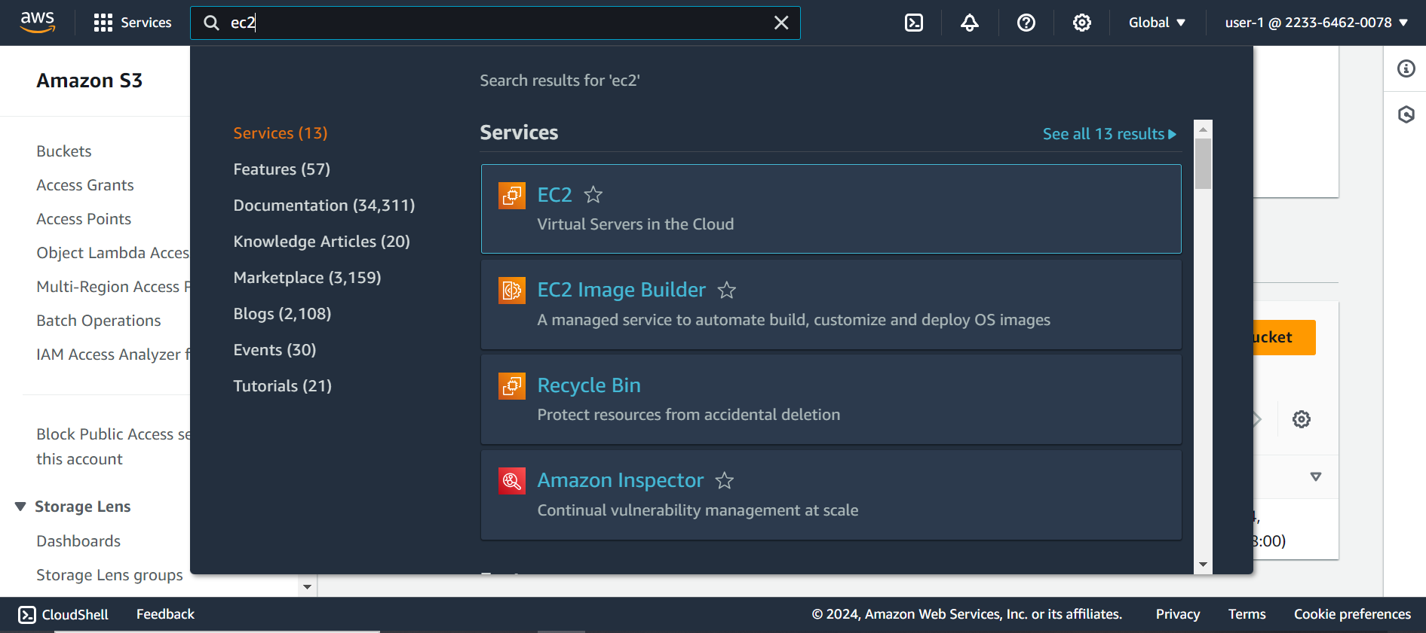

In the services menu, search up “EC2” and click on it.

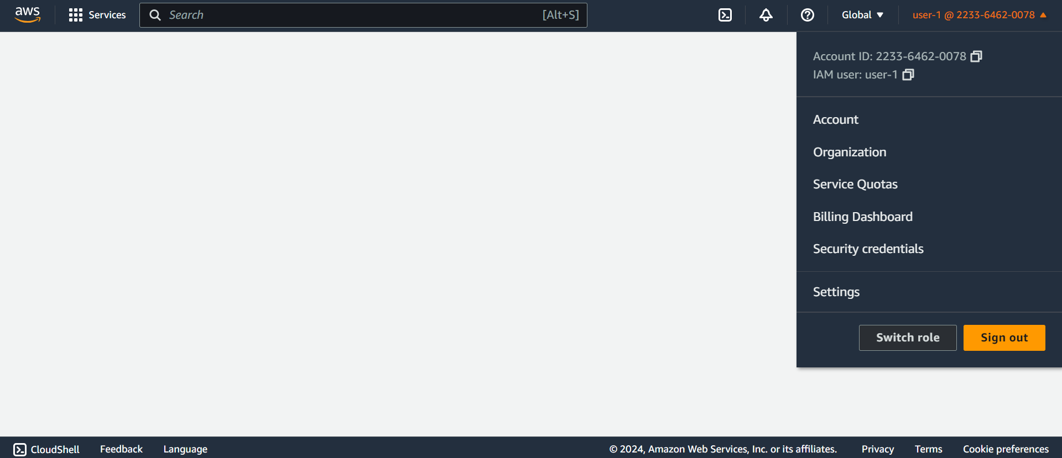

You will now have to sign in as user-2 so you must first sign out of user-1.



Sign in with username as “user-2” and enter in the password “Lab-Password2”

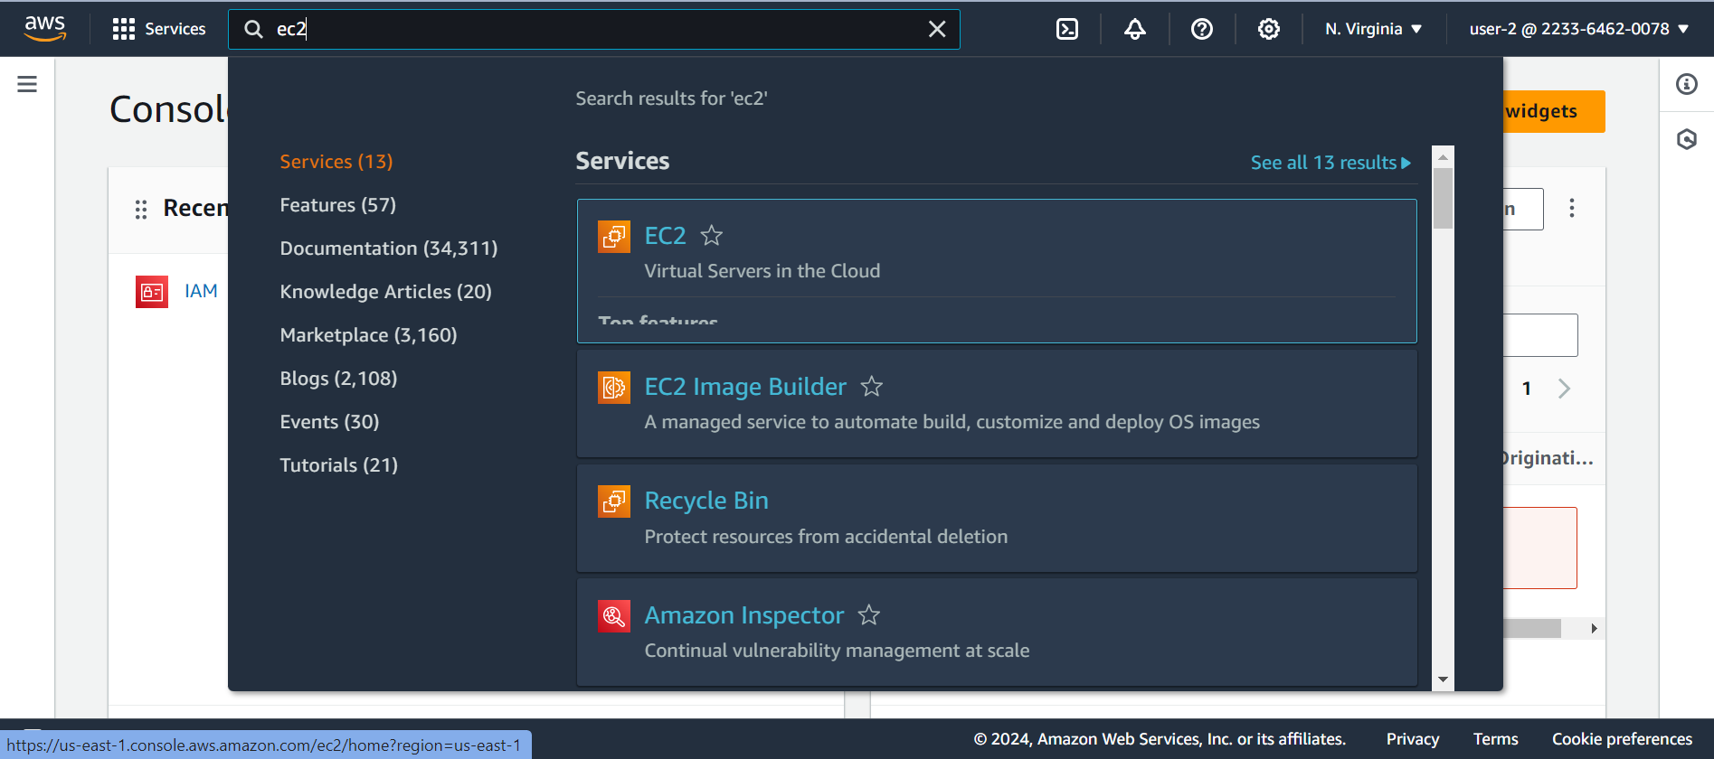

In the services menu search EC2 and click on it.

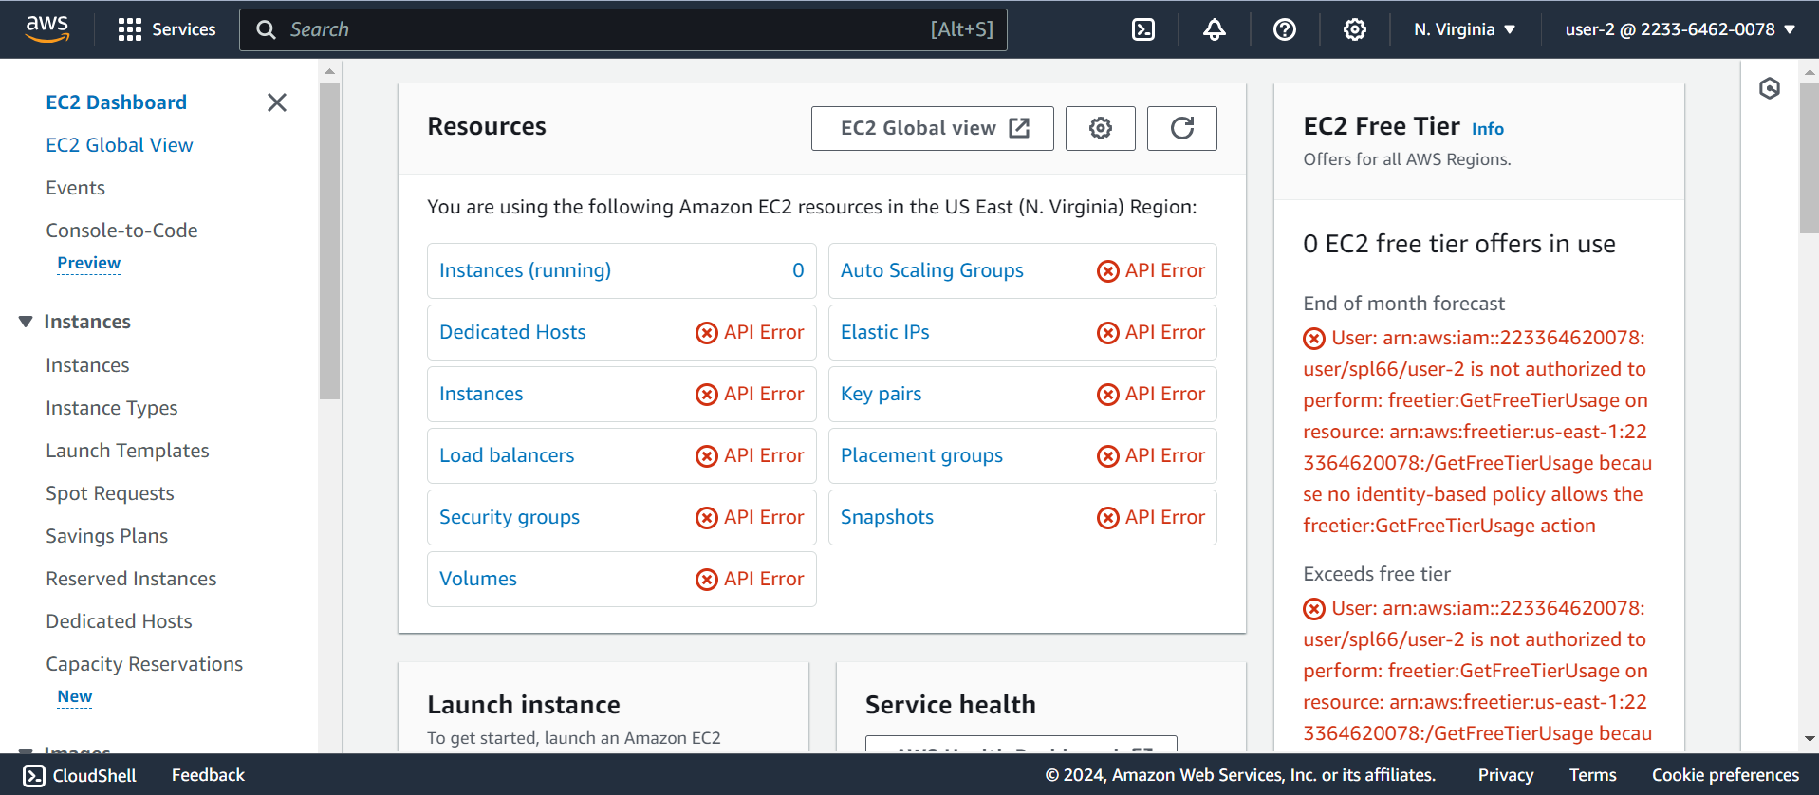

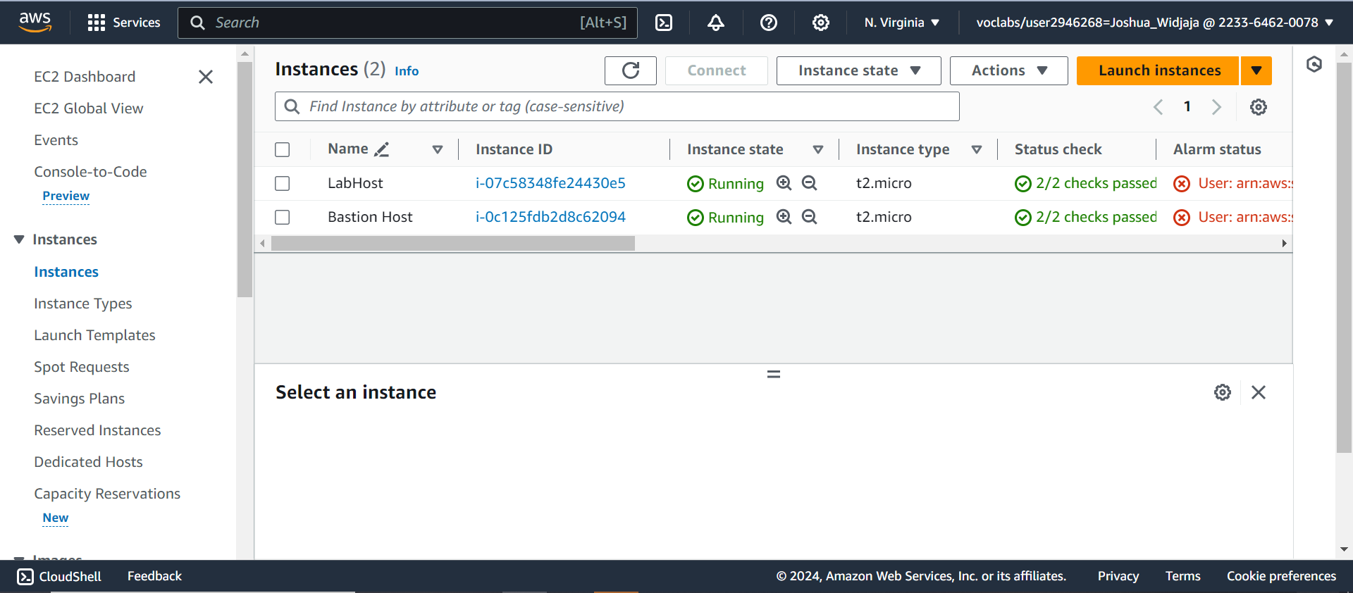Check the box next to the instance “LabHost”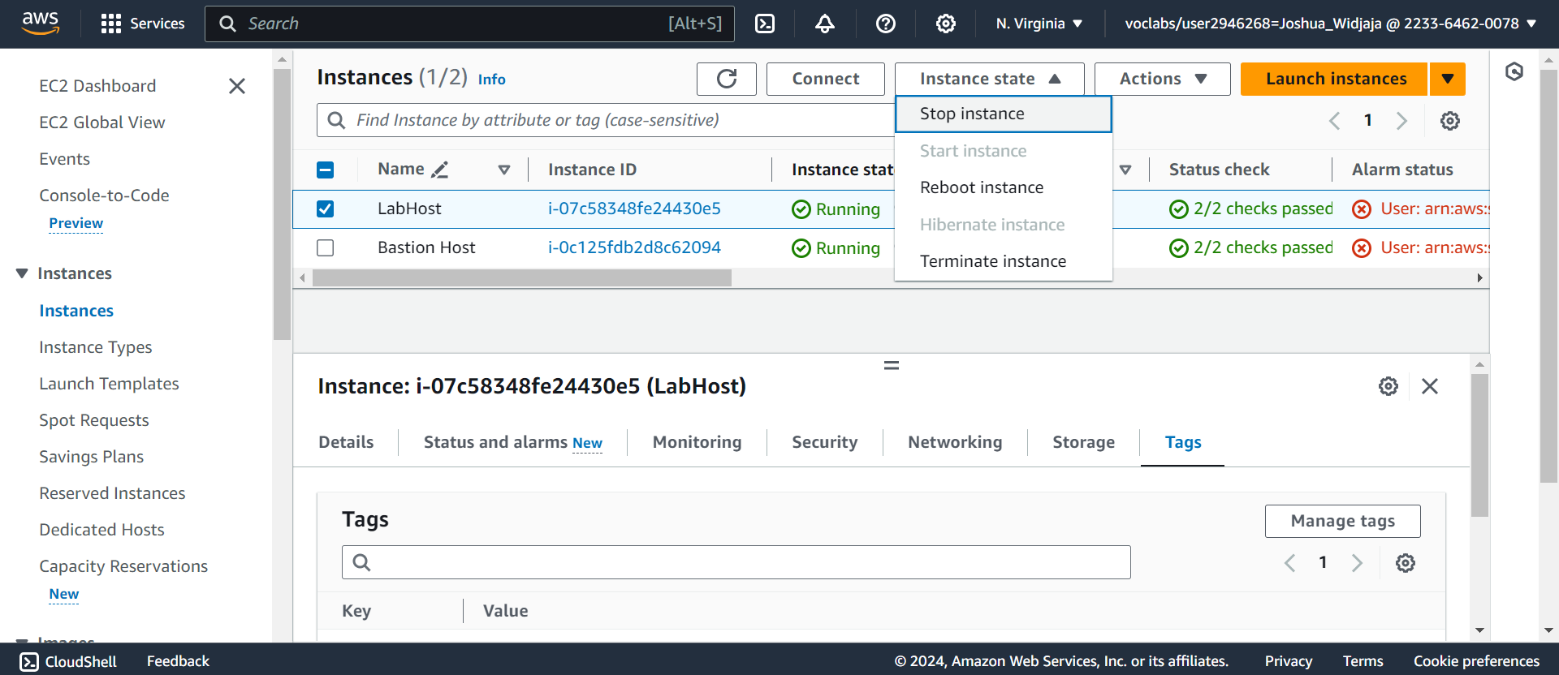

Select instance state and click “stop instance.” The instance will enter the stopping state and will shut down.

**Conclusion:**

With this being the first AWS Lab, I picked up the basic skills on using the AWS management console as well as starting and stopping the lab. I was able to explore IAM users and Groups and their policies, learned how to add users to certain groups and manage access to applications, and the effects of the created policies on service access. Seeing the business scenario, I see that the skills I gained from this lab can be applied into the workforce.

AWS Lab 2: Build Your VPC and Launch a Web Server

Joshua Widjaja

P0-2 Cisco CCNP



**Purpose:**

The purpose of this lab was to use Amazon Virtual Private Cloud (VPC) to create your own VPC. With this you will add additional components to produce a customized network. You will learn how to create a security group in the AWS management console. Major concepts like configuring and customizing an EC2 instance to run a web server and launching the EC2 instance to run in a subnet in the VPC is also covered.

**Background Information:**

The main concept of this lab is built around the basics of Amazon Virtual Private Cloud (VPC). Amazon VPC is a service that allows you to provision a logically isolated section of the AWS Cloud where you can launch AWS resources. It gives you control over your virtual networking resources. These resources include the selection of IP address ranges, creation of subnets, and the configuration of route tables and network gateways. You can also customize the network configuration for your VPC as well as being able to use multiple layers of security.

A Virtual Private Cloud (VPC) is a virtual network logically isolated from other networks in the AWS Cloud. It is dedicated to your account and belongs to a single AWS region and can go through multiple Availability Zones. Once you create a VPC you can divide it into one or more subnets. A subnet is a range of IP addresses in a VPC which belong to a single Availability Zone. For higher availability, you can create subnets in different Availability Zones. Subnets can either be public (direct access to the internet) or private (no direct access to the internet).

Those are the basic components of a VPC. Here are the different networking options that VPC offers:

|  |
| --- |
| **Internet Gateway:** A scalable, redundant, and highly available VPC component allowing communication between instances in your VPC and the internet. It provides a target in your VPC route tables for internet-routable traffic. Not only that but it can also perform network address translation for instances with assigned public IPv4 addresses.  **Network Address Translation (NAT) Gateway:** Enables instances in a private subnet to connect to the internet or other AWS services but prevents the internet from initiating a connection with those specified instances.  **VPC Sharing:** Enables customers to share subnets with other AWS accounts in the same organization in AWS organizations. It also enables multiple AWS accounts to create their application resources into shared, centrally managed VPC. Lastly, VPC sharing enables you to decouple accounts and networks which result in fewer, larger, centrally managed VPCs which highly interconnected applications benefit from.  **VPC Peering:** A networking connection between two VPCs which enable you to route traffic between them privately. IP address ranges must not overlap.  **AWS Site-to-Site VPN:** Creates a secure connection between your data center and your AWS resources using IP Security tunnels.  **AWS Direct Connect:** Enables you to establish a dedicated, private network connection between your network and one of the data center locations. This private connection reduces network costs, increases bandwidth throughput, and provides a more consistent network experience than internet-based connections.  **VPC endpoints:** A virtual device that enables you to privately connect your VPC to supported AWS services and VPC endpoint services powered by AWS PrivateLink.  **AWS Transit Gateway:** Connects your VOCs and on-premises networks through a central hub. This connection simplifies your network and fixes complex peering relationships. |

**Lab Summary:**

1. Access the AWS Management Console
2. Create your personal VPC with the specific settings and view it.
3. Create two additional subnets for the VPC in a second Availability Zone.
4. Create a VPC Security Group which acts as a virtual firewall.
5. Launch a Web Server Instance: You will launch an Amazon EC2 instance into the new VPC and configure it to act as a web server.

**Configurations:**

|  |  |  |
| --- | --- | --- |
| Start Lab. After lab status is ready, exit out and click AWS. |  | |
| On the search box to the right of Services, search VPC and choose VPC to open VPC console. |  | |
| Click onto VPC dashboard and then choose “Create” VPC |  | |
| Configure the following VPC details in the VPC settings panel on the left as shown. |  | |
| To double check, your preview channel should look like this. Next, click “Create VPC” |  | |
| Once the loading is complete, click “View VPC.” |  | |
| To view settings of the resources, browse through VPC console links displaying the resource details. In the left navigation plane, choose subnets. |  | |
| Click “Create Subnet” |  | |
| Under “Select a VPC,” choose lab-vpc |  | |
| Under Subnet settings, input the following information as shown. Next, click create subnet. The second public subnet was created. |  | |
| Choose create subnet |  | |
| Under “Select a VPC,” choose lab-vpc |  | |
| Under Subnet settings, input the following information as shown. Next, click create subnet. The second private subnet is created. |  | |
| In the left navigation plane, click on “Route tables” |  | |
| Check the box next to “lab-rtb-private1-us-east-1a” and then in the lower pane, click on “routes.” Destination to 0.0.0.0/0 will go to NAT gateway. |  | |
| Under the explicit subnet associations, choose “edit subnet associations” |  | |
| Leave lab-subnet-private1-us-east-1a selected, but also select lab-subnet-private2. Choose save associations next. |  | |
| Select the lab-rtb-public route table and deselect any other subnets. In the lower pane, choose “routes.” Note that destination of internet bound traffic will be sent through internet gateway |  | |
| Under the explicit subnet associations, choose “edit subnet associations |  | |
| Leave lab-subnet-public1-us-east-1a selected, but also select lab-subnet-public2. Next choose save associations. |  | |
| In the left navigation plane and under security, choose security groups |  | |
| Choose create security group |  | |
| Configure the following settings for basic details as shown. Choose the X to remove the currently selected VPC, then from the drop down list choose lab-vpc |  | |
| In the inbound rules pane, select add rule. |  | |
| Configure the following settings in the inbound rules. Then choose create security group at the bottom of the page. |  | |
| In the search box to the right of Services, search EC2 and select it to open the EC2 console |  | |
| From launch instance menu choose launch instance. |  | |
| Name your instance “Web Server 1” |  | |
| Under quick start, keep Amazon Linux and amazon Linux 2023 AMI selected |  | |
| In the instance type panel, keep default t2.micro selected. From key pair name menu, select vockey. |  | |
| Next to network settings, choose edit. |  | |
| Under network settings, input the following configurations. In the common security groups menu dropdown, select web security group. | |  |
| Keep the default configure storage settings. Expand the advanced details panel. | |  |
| Scroll to the bottom of the page and paste the given code into the User Data box. This script will run with root user permissions on the guest OS of the instance. Click Launch Instance. | |  |
| Scroll to the bottom and choose View all instances. | |  |
| Wait until Web Server 1 shows 2/2 checks passed in the Status check column. Then check the box next to Web Server 1. | |  |
| Copy the Public IPv4 DNS value shown in the Details tab at the bottom of the page. | |  |
| Paste the copied link into a new tab. You should see a web page displaying the AWS logo and instance meta-data values. | |  |

**Conclusion:**

After the completion of this lab, I was able to gain the important skill of knowing how to build my own VPC and launching a web server. Furthermore, I learned to create a VPC, create subnets, configure a security group, and to launch an EC2 instance into a VPC. The implementation of being able to see a web page displaying the AWS logo and instance meta-data values was eye-opening, as it felt applicable to a real situation.

AWS Lab 3: Introduction to Amazon EC2

Joshua Widjaja

P0-2 Cisco CCNP



**Purpose:**

The major purpose of this lab was familiarizing us with the important concept of Amazon Elastic Compute Cloud (EC2). The lab also provides us with a basic overview of launching, resizing, managing, and monitoring an Amazon EC2 instance. You should acquire skills such as launching a web server with termination protection enabled, monitoring your EC2 instance, modifying the security group that your web server is using to allow HTTP access, resizing your Amazon EC2 instance to scale, exploring EC2 limits, testing termination protection, and terminating your EC2 instance.

**Background Information:**

The main concept of this lab is centered around the basic functions of Amazon EC2. Amazon Elastic Compute Cloud (Amazon EC2) is a web service that provides resizable compute capacity in the cloud. It is designed to make web-scale cloud computing easier for developers. It’s simple web service interface allows you to obtain and configure capacity with the friction as low as possible, providing complete control of your computing resources. Amazon EC2 reduces the time required to obtain and boot new server instances to minutes, allowing quick scale capacity, both up and down, as your computing requirements change. It also changes the economics of computing by allowing you to pay only for capacity you actually use, providing developers the tools to build failure resilient applications to minimize common failure scenarios.

Amazon Web Services (AWS) offers many compute services listed below and explained:

|  |  |
| --- | --- |
| Name of Compute Service | What the compute service offers |
| Amazon Elastic Compute Cloud (Amazon EC2) | * Provides resizable virtual machines. |
| Amazon EC2 Auto Scaling | * Supports application availability by allowing you to define conditions that will automatically launch or terminate EC2 instances. |
| Amazon Elastic Container Registry (Amazon ECR) | * Is used to store and retrieve Docker images. |
| Amazon Elastic Container Service (Amazon ECS) | * A container orchestration service that supports Docker. |
| AWS Elastic Beanstalk | * Provides a simple way to run and manage web applications. |
| AWS Lambda | * A serverless compute solution. * You pay only for the compute time that you use. |
| Amazon Elastic Kubernetes Service (Amazon EKS) | * Enables you to run managed Kubernetes on AWS |
| Amazon Lightsail | * Provides a simple-to-use service for building an application or website |
| AWS Batch | * Provides a tool for running batch jobs at any scale |
| AWS Fargate | * Provides a way to run containers that reduce the need for you to manage servers or clusters |
| AWS Outposts | * Provides a way to run select AWS services in your on-premises data center |
| AWS Serverless Application Repository | * Provides a way to discover, deploy, and publish serverless applications |

Elastic in EC2 refers to how you can easily increase/decrease the number of servers you run to support an application automatically whilst increasing/decreasing the size of existing servers. Compute is the reason why most users run servers, which is to host running applications. These actions require compute resources such as processing power (CPU) and memory (RAM). Cloud refers to run EC2 instances that are hosted in the cloud.

You can launch instances of any size into an Availability Zone anywhere in the world. You can launch instances from Amazon Machine Images (AMIs), which are virtual machine templates. You launch EC2 instances from an AMI template into a VPC in your account. Then you can chooser from many instance types including combinations of CPU, RAM, storage, and networking capabilities. You can also control traffic to and from instances by using security groups. User data enables you to specify a script to run the first time an instance launches and only instances that are backed by Amazon EBS can be stopped. Lastly, you can use Amazon CloudWatch to monitor EC2 instances.

**Lab Summary:**

1. Access the AWS Management Console
2. Launch your Amazon EC2 instance with the given configuration settings.
3. Monitor the Instance you created.
4. Update your security group and access the web server.
5. Resize your instance: Configure Instance Type and EBS Volume.
6. Explore EC2 Default Limits.
7. Test Termination Protection on your instance

**Configurations:**

|  |  |
| --- | --- |
| Click services and then click onto Compute. Then Choose EC2 |  |
| On the launch instance menu, select Launch instance. |  |
| Name the instance “Web Server.” Keep default amazon linux and Amazon Linux 2023 AMI. |  |
| In the instance type panel, keep the default t2.micro selected. Select vockey as the key pair name. |  |
| Click edit next to network settings. |  |
| Enter the following information under network settings. Under Inbound security group rules, remove the rule. |  |
| Keep the default settings under configure storage. Expand advanced details. |  |
| Scroll down to Termination protection menu and select Enable. |  |
| Copy the given code and paste it under user data. At the bottom of the Summary panel choose Launch instance. |  |
| You will receive a success message. Click view all instances. |  |
| In the instances list, select Web Server. Review the information displayed in the details tab. Wait for your instance state to be running and status check 2/2. |  |
| Choose the status and alarms tab. Notice that both System reachability and Instance reachability checks have passed. |  |
| Choose the Monitoring tab. You can choose three dots and select enlarge to see expanded view of metric. |  |
| In the actions dropdown, select Monitor and troubleshoot and then select get system log. |  |
| Scroll through output and note that HTTP package was installed from the user data you added when creating the instance. Choose Cancel. |  |
| With web server still selected, in actions menu, select monitor and troubleshoot and then get instance screenshot. |  |
| This shows what your Amazon EC2 instance console would look like if a screen were attached to it. Click cancel. |  |
| Ensure web server is still selected. In details tab, copy the public IPv4 address. |  |
| Paste the copied address in a new tab in your web browser. You won’t be able to access because the security group isn’t permitting inbound traffic on port 80. Return to EC2 Console Tab. |  |
| In the left navigation pane, choose Security Groups. |  |
| Check Web Server security group. Choose Inbound rules tab. |  |
| Notice the security group has no inbound rules. Choose edit inbound rules. |  |
| Select Add rule and then configure the following. Type is HTTP. Source is Anywhere-IPv4. Choose Save rules. |  |
| Return to the web server tab previously opened and refresh the page. You should see the message “Hello From Your Web Server!” | image |
| On EC2 Management Console, choose instances. |  |
| In the Instance State menu, select stop instance. Then choose stop instance. |  |
| In actions menu, select Instance settings and then change instance type. |  |
| Make the instance type t2.small. Choose apply. |  |
| With Web server still selected, choose storage tab. Select name of Volume ID. |  |
| In the actions menu select modify volume. |  |
| Change Size (GiB) to 10 and choose modify. Choose modify again to confirm and increase the size of the volume. |  |
| In the left navigation plane, select Instances. |  |
| With web server still selected, click instance state, and select start instance. |  |
| On the Services menu, search “service quotas” and select it |  |
| On the left navigation pane, select AWS Services and in its search bar, search EC2 and select Amazon Elastic Compute Cloud (Amazon EC2) |  |
| Under the Service quotas search bar, search “running on-demand.” Do not select anything but observe the filtered list of service quotas matching the criteria. |  |
| Go back to AWS management console. Click back onto EC2 to return back to EC2 console. |  |
| On the left navigation pane, choose instances. With Web Server selected, choose instance state and select Terminate instance. Choose Terminate. |  |
| The error is a safeguard is to prevent accidental termination of an instance. Under Actions menu, select Instance settings and Change termination protection. Uncheck the box next to enable. Choose save. |  |
| With Web Server still selected, choose instance state and then Terminate instance. You have successfully terminated the instance. |  |

**Conclusion:**

Throughout this lab I was able to learn one of the most important concepts of Amazon Web Services, Amazon Elastic Compute Cloud. After completing this lab, I am now able to launch a web server with termination protection enabled, monitor my EC2 instance, modify the security group that my web server is using to allow HTTP access, resize my Amazon EC2 instance to scale, explore EC2 limits, test termination protection, and terminate my EC2 instance. Knowing how to test termination protection and to terminate an instance is key knowledge that I will be taking with me into the future.